Stroke Foundation

Annual Review 2020
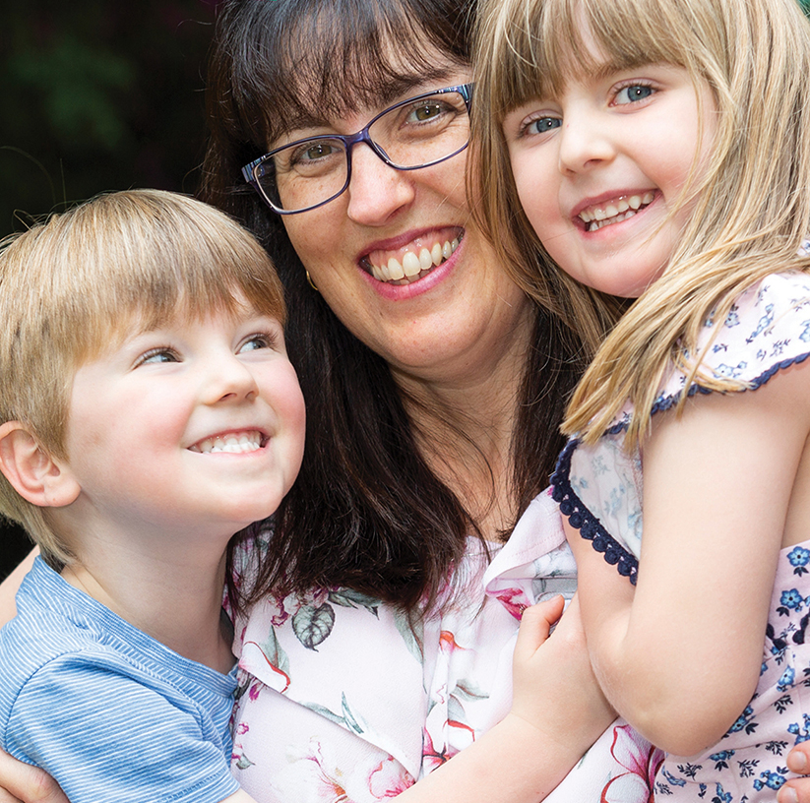
Childhood survivor of stroke, Georgia Peacock with her family.

strokefoundation.org.au

From the President and Chief Executive Officer
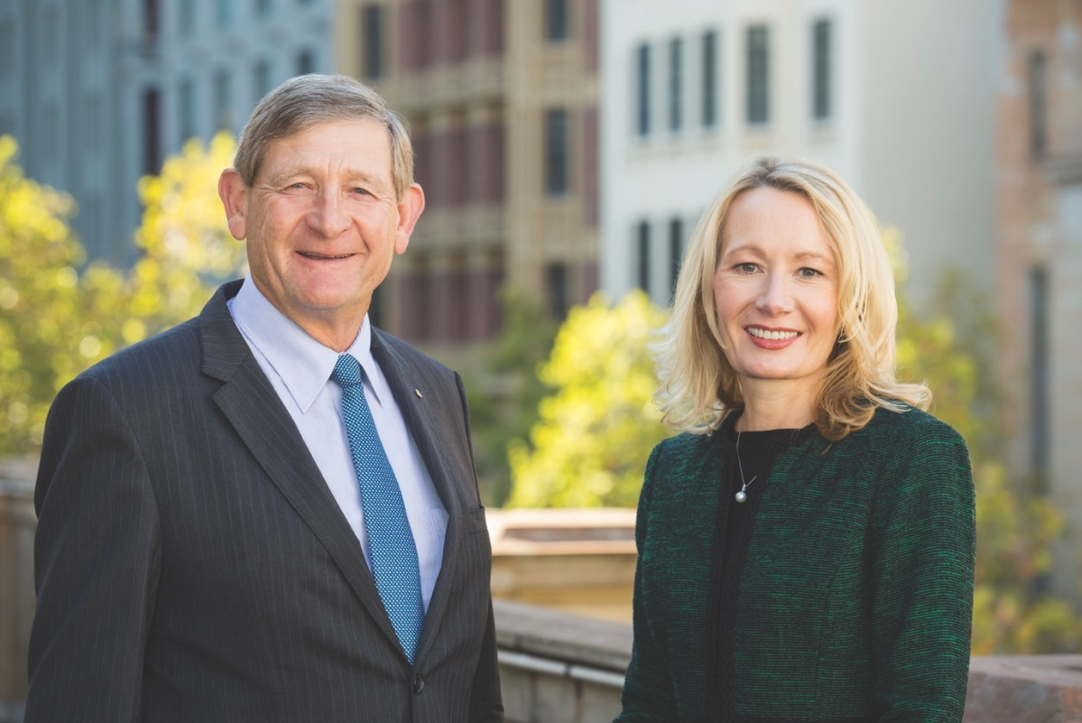
Thank you for standing with us as we continued our mission during unprecedented challenges.
In 2020, the world faced a new threat and a changed reality when the World Health Organisation (WHO) announced the coronavirus (COVID-19) as a global pandemic. The impact was profound and immediate with restrictions on public movement, mandatory facemask wearing and major disruptions to health and community services.
With your support, Stroke Foundation leaned-in to the challenges of 2020 knowing the services we provide for the stroke community were needed more than ever. We quickly moved our people to remote working ensuring our key services were a constant for those in need of advice, support and information. We partnered with the community to identify where gaps existed and acted, adapting and evolving with the environment around us.

The economic impact of stroke in Australia, 2020
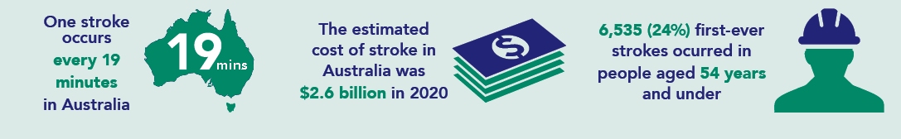
Proudly, Stroke Foundation played an important role in the management of COVID-19 across the nation. Technology and processes Stroke Foundation developed and tested with Cochrane Australia as part of a Living Guidelines for Stroke Management pilot project were adapted to provide our health professionals with clinical guidance for managing patients with COVID-19. It is our vision to see the tools and systems we have developed to provide up to date, accessible guidelines for stroke be expanded to other disease areas.
Our ability to pivot our learnings to respond rapidly and use the systems to produce guidelines for COVID-19 us a demonstration of the value this model brings to the Australian health care system.
Outside of the COVID-19 response, Stroke Foundation focused on helping more Australians live well after stroke. Recovery from stroke can be a long and hard journey, with its impact extending beyond the individual survivor.
The extent of stroke’s impact and the opportunity to address it was quantified in the release of two major new reports; The economic impact of stroke in Australia, 2020 and No Postcode Untouched, Stroke in Australia 2020. The reports showed an estimated 27,428 Australians experienced stroke for the first time in their lives in 2020, and there were an estimated 445,087 survivors of stroke living in the community. Alarmingly, the economic cost of stroke exceeded $6.2 billion in 2020, with a further $26.0 billion in lost wellbeing – due to short and long-term disability, and premature death.
The reports also highlighted the opportunity to act now, to reduce the burden of stroke.
For the first time, Stroke Foundation acted to improve outcomes for our littlest survivors of stroke and their families. Thanks to your generosity, Our Family’s Stroke Journey was launched, providing families with an evidenced-based road map to help navigate life after stroke. Further, Stroke Foundation secured funding from the Medical Research Future Fund’s (MRFF) Mission for Cardiovascular Health for a world-first multi-centre clinical trial assessing the benefit of administering established time-critical adult treatments in children impacted by stroke.
With your support, Stroke Foundation took evidence-based interventions highlighted in 2019 National Strategic Action Plan for Heart and Stroke – currently under consideration by Government – and began to implement them.
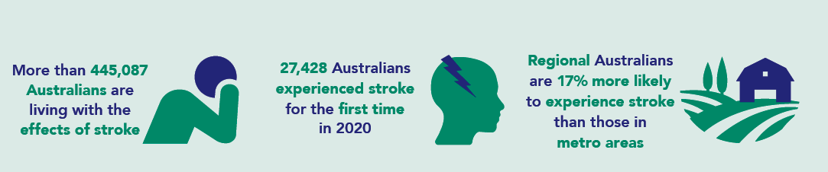
Stroke Foundation also began the Young Stroke Project, a co-designed project with survivors and carers, which aims to empower working-age Australians to find their ‘new normal’ after stroke. Young stroke is an emerging area of need in the health system, with The economic impact of stroke in Australia, 2020 report providing evidence of increased incidence of stroke among younger people aged 35–54 years.
The year 2020 also saw Stroke Foundation continue its commitment to equity of access to emergency stroke treatment. The Melbourne-based Stroke Ambulance continued to slash treatment times compared with standard hospital care.
Lessons learned from this impressive pilot project were utilised to create a new vision for accessible emergency stroke treatment in regional and rural Australia. The Australian Stroke Alliance Golden Hour Project proposal is aiming to develop the next generation of lightweight, portable brain scanning technology and even a world-first stroke air ambulance. Stroke Foundation is proud to be a partner in this ambitious proposal.
Being resilient, thinking outside the box, adapting quickly, and working with our community to solve problems were central to our work in 2020. Stroke Foundation will take this approach into 2021, as we celebrate all that we have achieved over the past 25 years and set our sights on preventing, treating and beating stroke over the coming decade. It is timely that in 2021, our 25th anniversary year, Stroke Foundation will formally welcome its first female President to lead this important next phase.
We are making gains in improving outcomes from stroke, however there is much more to be done and we can only achieve our mission with your continued and vital support. This Annual Review is a testament to you: our generous supporters, our Board and Committee members, our workforce, our many volunteers, the survivors of stroke, their loved ones, health professionals and researchers. Thank you for continuing to prevent stroke, save lives and enhance recovery.

Professor James Angus AO, President.
Sharon McGowan, Chief Executive Officer.

Stroke during the COVID-19 pandemic
COVID-19 has demonstrated the effectiveness of decisive public health measures and a comprehensive communication strategy designed to prevent disease, diagnose quickly and treat effectively those confirmed with the disease. Many of these approaches apply equally to prevention, treatment and recovery from stroke and other chronic disease. We must learn from these approaches for the future wellbeing of Australians.
In Australia, visits to the GP declined during the pandemic, leading to decrease in risk assessments and management of chronic conditions and calls to triple zero (000). The decline resulted in delays in treatment and the inability to be connected to rehabilitation services or the secondary prevention information patients needed to recover well.
With your support, Stroke Foundation continued to be there where and when we were needed most, delivering support and connection, including:
- F.A.S.T. (Face. Arms. Speech. Time.) signs of stroke awareness.
- COVID-19 community information updates.
- StrokeLine – Free national helpline 1800 STROKE (1800 787 653) staffed by health professionals, providing practical and confidential advice.
- StrokeLine Outbound (QLD, ACT and TAS) – supporting survivors of stroke and their families on their return home, connecting them to services and providing information including prevention of further strokes.
- EnableMe – Online community and resource guiding recovery and connecting survivors and carers (enableme.org.au).
- InformMe – Online resource for health professionals in stroke providing the latest guidance in utilising telehealth (informme.org.au).
- Expertise, technology and processes pivoted to support the National COVID-19 Clinical Evidence Taskforce.

Goal 1: Fewer preventable strokes in Australia
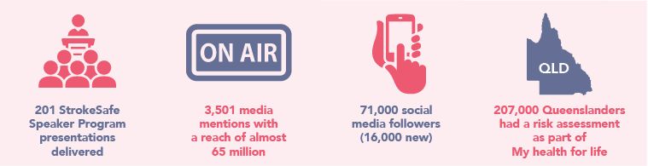
More than 80 percent of strokes can be prevented. With our population aging and our lifestyle becoming more sedentary, many of us are unaware of our stroke risk and are unable to be proactive and take back control.
Uncontrolled high blood pressure remains the single largest risk factor for stroke. Therefore, raising awareness of the link between high blood pressure and stroke, and empowering Australians to know their stroke risk and understand how to manage it is vitally important.
With your continued support, Stroke Foundation is increasing community understanding of the major risk factors for stroke. This is a crucial step towards a healthier Australia with fewer preventable strokes occurring in our community.

Ryman Healthcare Mobile Health Screening
The Ryman Healthcare Mobile Health Screening Service, delivered in partnership with Stroke Foundation, visited 22 sites across Victoria in early 2020: including bowls clubs, farmers markets and universities. A total of 56 percent of those who had their blood pressure checked, were found to be at high risk of stroke and referred to appropriate GP/primary care services. Services were suspended from March to December due to COVID-19 restrictions.

Tasmanian Community Innovations Grant
A stroke prevention framework, funded by the Tasmanian Government, was delivered to help Tasmanians access a free, interactive health check to reduce their stroke risk. A total of 2,376 Tasmanians visited a health check station and 19 percent of those who participated in a follow-up check showed health improvements.

My health for life
By the end of 2020 over 207,000 Queenslanders had a risk assessment and over 10,000 completed the program. The program has continued to demonstrate successful outcomes with 70 percent of participants reducing their waist circumference and the average number of mentally unhealthy days identified by participants dropped from 6.4 to 4.8 days.

Health Promotion Advisory Sub-committee
The Health Promotion Advisory Sub-committee provided expert advice and input on a number of policy submissions to Government and other consultations: including the Therapeutic Goods Administration (TGA) Consultation on Proposed Amendments to the Poison Standard (Nicotine), Royal Australian College of General Practitioners (RACGP) Update of Guidelines for Preventive Activities in General Practice, Development of the National Preventive Health Strategy, National Health and Medical Research Council (NHMRC) Draft Australian Guidelines to Reduce Health Risks From Drinking Alcohol, and Senate Select Committee Inquiry into Tobacco Harm Reduction.

Promoting Healthy Lifestyles
Incredibly, 3,501 individual media mentions were generated with a reach of almost 65 million.
Stroke Foundation’s social media community grew by 16,000 to more than 71,000 followers. Our strokefoundation.org.au website had 619,283 unique visitors in 2020, resulting in 802,645 website sessions. In addition, users spent 14 percent more time on the site than in 2019, and also explored more web pages.

StrokeSafe Speaker Program
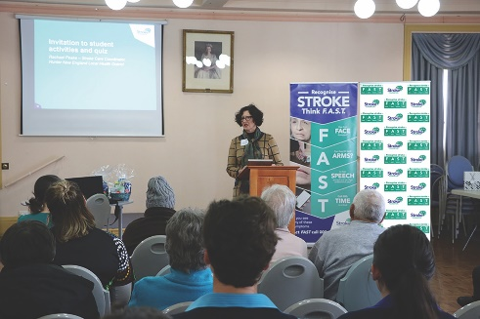
For the first time, the StrokeSafe Speaker Program was also delivered virtually in 2020. There were 201 presentations delivered to community groups, events, and workplaces, reaching more than 5,000 Australians with life-saving F.A.S.T. (Face. Arms. Speech. Time.) signs of stroke and stroke prevention messages. Virtual presentations increased Stroke Foundation’s reach into regional and rural Australia.
An online training platform for new StrokeSafe Speakers was developed with the support of the Australian Federal Government, removing barriers to recruitment of StrokeSafe speakers from regional areas.

Case Study: Jo Cordell Cooper
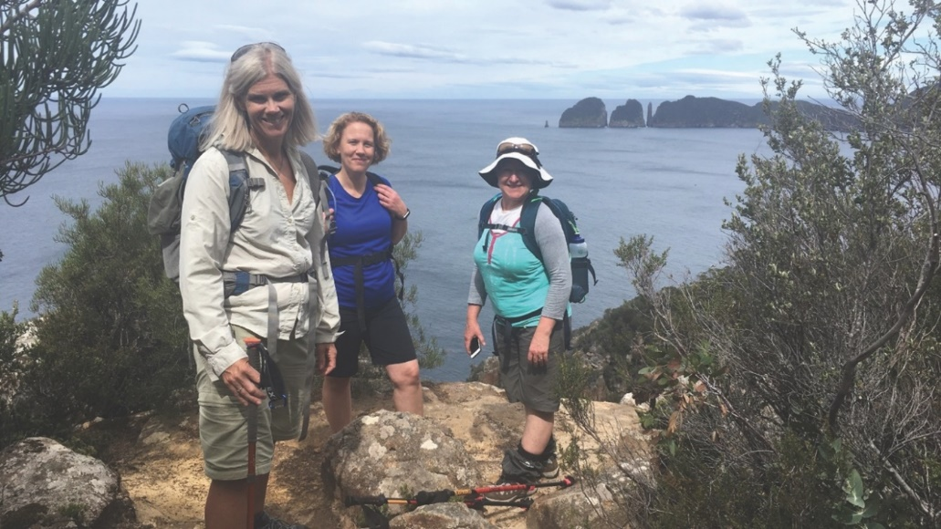
Tasmania’s Jo Cordell Cooper has a passion for exercise, healthy living and encouraging people to get moving to reduce their stroke risk. Jo’s father Ron suffered two strokes and lived with poor health for many years before sadly passing away.
After seeing first-hand, the devastating impact stroke can have on families, Jo decided to take action to help other people and families avoid this disease. Jo established the Tasmanian Iconic Walks, an annual bushwalk through the scenic Tasman National Park, which raises awareness of stroke, makes participants focus on their own health and raises funds for Stroke Foundation.
In the past three years Jo and her team have raised almost $120,000 to support vital Stroke Foundation programs to help survivors of stroke and their families live well and avoid recurrent stroke.
“Stroke denied my Dad simple pleasures like walking, knowing us, and even eating was a struggle. My father and his situation became my inspiration. I wanted to help at a deep level,’’ Jo said.
“Physical inactivity is one of the greatest risk factors for stroke behind high blood pressure, but we can do something about it. There are so many health benefits from finding an activity you love and moving your body.”

Goal 2: Ensure all Australians have access to evidence-based stroke treatment
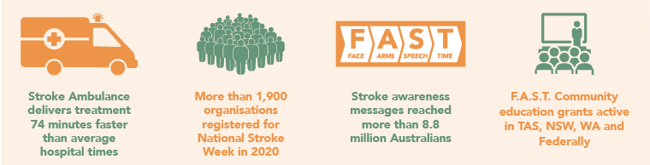

With the right treatment, at the right time, many people will recover from stroke. However, not all Australians have access to these vital treatments when they are most needed.

When a stroke strikes, up to 1.9 million brain cells can die every minute; but quick treatment can stop this damage. Stroke treatment is time critical, the earlier treatment is delivered, the better the outcome for patients with stroke. With new life-saving treatments being implemented, survivors of stroke now have a better chance of a meaningful recovery.
Together, we continue to make progress towards ensuring all Australians have access to evidence-based stroke treatment and care.

Stroke Ambulance
A Stroke Ambulance brings emergency stroke diagnosis and treatment to the patient. Equipped with the latest diagnostic technology, including a brain scanner and telemedicine equipment, and specialist staff on board, Stroke Ambulances improve outcomes for stroke patients.
- After three years of operation, the Melbourne-based Stroke Ambulance (or Mobile Stroke Unit) provides treatment after onset up to 74 minutes faster compared to Australian hospital treatment and 40 minutes faster compared to metropolitan Melbourne hospitals.
- The New South Wales (NSW) Government announced a Stroke Ambulance was set to be trialled in the state. This builds on the success of the Melbourne-based Stroke Ambulance.

Australian Stroke Alliance
Stroke Foundation is an essential partner in the Australian Stroke Alliance and will lead consumer engagement and clinician education in this ground-breaking national proposal. The work of the Australian Stroke Alliance is supported in Stage 1 by a $1 million grant as part of the Australian Government’s Medical Research Future Fund Frontiers initiative, as well as support from philanthropic partners.

Emergency stroke telehealth services and treatment pathways
Via the utilisation of telehealth networks, neurologists provide around-the-clock support to regional clinicians. Specialists are available to review a patient’s brain scan via computer software remotely, then provide diagnosis, timely treatment advice and assist with rapid transfer to metro hospitals for more advanced treatments where appropriate. Stroke Foundation has long advocated for stroke telehealth services to be rolled-out nationally.
Established networks are located in Victoria which expanded its service in 2020 to include two regional hospitals in Tasmania, and also an operational service in South Australia. Building on these networks in 2020:
- NSW Telestroke Service
Up to 23 rural and regional NSW hospitals will be added to the jointly Federal and State Government funded Telestroke service in the next three years. The NSW Telestroke Service is coordinated by the Prince of Wales Hospital in Sydney.
- WA Statewide Telestroke Service
A $9.7 million commitment from WA Government to expand the Statewide Telestroke Service, as part of WA Recovery Plan delivers on a key focus of the Sustainable Health Review to provide more telehealth services so patients with suspected stroke can access specialist consultant expertise 24/7.

F.A.S.T. across the country
Stroke Foundation’s 2020 population health survey showed that just 16% of Australians knew two or more signs of stroke unprompted.
WA F.A.S.T. grant of $800,000 over four years conducted a number of activities in 2020; including distributing F.A.S.T. resources to pharmacies, online not-for-profit shopping delivery service, 20 retirement villages to 675 residences and 10 public libraries. A social media campaign promoted F.A.S.T. in the South West region, 27 face-to-face F.A.S.T. education talks were held, and four community events were attended.
In partnership with NSW Health, the NSW F.A.S.T. Community Education program supported the roll out of the new NSW Telestroke Service by generating 339 individual media mentions across print, radio, television and online reaching an estimated audience of 6.3 million. There were 310 people who attended a StrokeSafe talk in regional NSW.
Stroke Foundation welcomed a four-year investment from the ACT Government into a specialist F.A.S.T. education program tailored to maximise the benefits of Canberra’s Walk-in Centers. Clinician education will be partnered with health checks and resources to prevent stroke and improve access to stroke treatment amongst the vulnerable.
- As part of the Tasmanian F.A.S.T. grant the StrokeSafe message was promoted and resources provided to the local community; supporters delivered 2,000 F.A.S.T. magnets to households in Launceston and 725 F.A.S.T. magnets to households in the Derwent Valley communities.
- The Tasmanian Government awarded Stroke Foundation a $440,000 budget allocation over two years for continuation of the F.A.S.T. Community of Practice and Stroke Outreach Program.

Clinical Guidelines
With the help of more than 100 clinical experts and 28 consumers the innovative ‘living’ stroke guidelines model continued to mature. Changes to six recommendations were approved by NHMRC, with updated research added to almost all topics ensuring evidence-based clinical guidance is readily and easily available to health professionals and consumers across Australia.

National Stroke Week 2020
National Stroke Week was held from 31 August – 6 September 2020, with more than 1,900 organisations and individuals registering across the country: including health organisations, workplaces and community groups hosting awareness activities, online events and webinars. The community was encouraged to learn the signs of stroke and become a F.A.S.T. Hero. Stroke Week messages reached more than 8.8 million Australians.

F.A.S.T. Federal Grant Project
Stroke Foundation developed and launched a new F.A.S.T. signs of stroke campaign targeting regional and culturally and linguistically diverse communities.
Priority populations were identified based on health literacy, stroke incidence and access to stroke services:
- Federal electorates targeted include Flinders, Mallee, Lyne, Page, Wide Bay, Hinkler, Capricornia, Barker, Braddon, Forrest.
- Languages targeted include Greek, Italian, Cantonese, Mandarin, Korean, Vietnamese, Arabic, Hindi.
The campaign is funded by an $800,000 grant from the Federal Government in response to the National Strategic Action Plan for Heart Disease and Stroke. The Action Plan is currently under consideration by Governments at all levels.

Case Study: Tevita Fifita
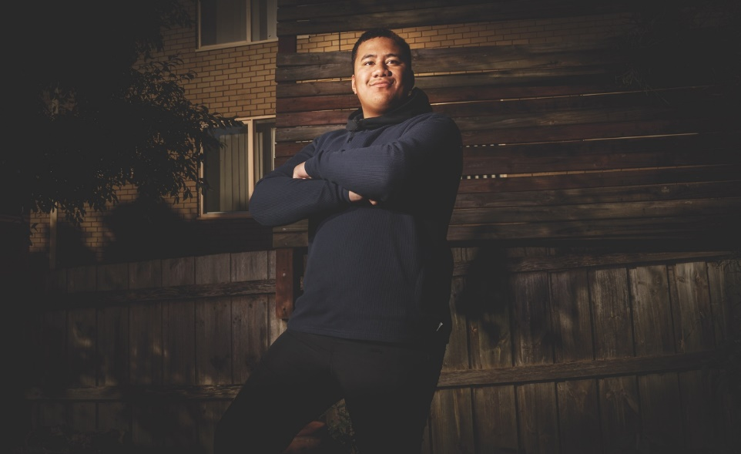
Victorian boy Tevita Fifita may have saved his mum Meliame’s life by recognising the signs of stroke and calling triple zero (000).
Tevita was 10 years old when Meliame had a stroke. Tevita had learnt the F.A.S.T. signs of stroke as part of a first aid class at school.
The pair were home alone when Meliame experienced a facial droop and was unable to move her left side.
“Mum told me to call Dad who was at work, but instead I called an ambulance so we could get help straight away.”

Goal 3: Enhance recovery to help Australians live well after stroke
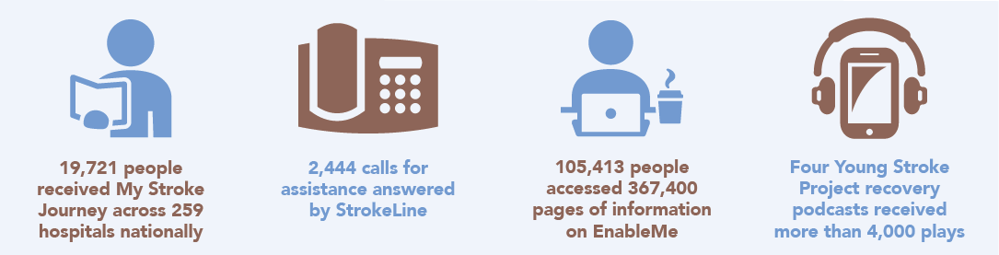
A stroke has long lasting and far-reaching effects. Affecting both the survivor and their family, recovery can be a long and challenging road, both physically and mentally.

With your help, Stroke Foundation can continue to ensure both practical tools and programs are available to provide survivors and their loved ones with the confidence and support they need to live well. We will stand alongside survivors of stroke and their families and provide support on their journey to live well after stroke.

National Stroke Audit
A total of 111 rehabilitation services participated in the annual National Stroke Audit. 2,842 case notes were reviewed to assess the quality of hospital-based stroke rehabilitation care in Australia. The audit identifies gaps in care and is used to improve care outlined in the guidelines.

My Stroke Journey
The definitive guide for survivors of stroke, their families, and carers for navigating the journey from hospital to home after stroke, and beyond. With your support, this resource is provided freely to all hospitals.
- 19,721 people received My Stroke Journey while in hospital.
- 259 hospitals delivered the resource nationally.
Our Stroke Journey, for Aboriginal and Torres Strait Islander communities, is in development and will be launched in 2021.

$4 million for childhood stroke
In a world-first, Stroke Foundation is transforming the care of children with stroke by decreasing time to diagnosis and increasing the number of children receiving time-critical stroke therapies.
Each year, an estimated 500 babies and children experience a stroke in Australia.
The Australian Paediatric Acute Code Stroke (PACS) study is a partnership project between Stroke Foundation and the Murdoch Children’s Research Institute (MCRI), health professionals and patients.
Childhood stroke was named among the first priorities of the Federal Government’s Medical Research Future Fund Cardiovascular Mission.
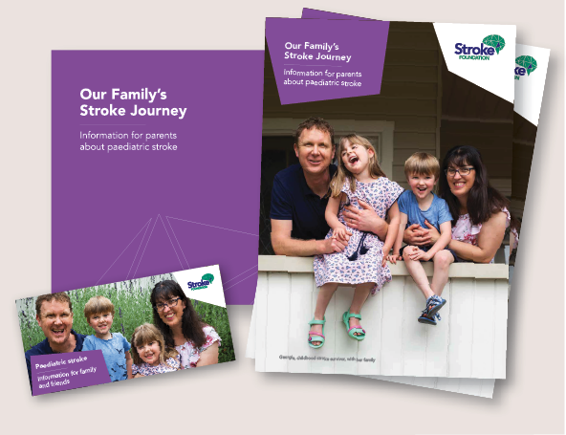
Building on this work, with your support Stroke Foundation launched Our Family’s Stroke Journey information pack for parent s and families of childhood survivors of stroke in September. The information pack provides an evidence-based road map for navigating life after stroke for our littlest survivors. 1,650 Our Family’s Stroke Journey recovery guides were distributed to major paediatric hospitals across Australia.

Culturally and Linguistically Diverse (CALD) Communities Project
Commencing late 2020 and focused on improving life after stroke for culturally diverse communities, information for survivors of stroke will be translated into eight languages.

Connecting communities
EnableMe is Stroke Foundation’s online platform designed with survivors of stroke to provide information and resources across the stroke journey. In 2020 EnableMe was accessed by 105,413 survivors of stroke, their families, carers and supporting health professionals; together 367,400 pages of information were accessed in 2020.
A total of 2,444 survivors of stroke, their carers and families utilised StrokeLine, our free information and advice telephone helpline service staffed by health professionals, to obtain stroke support and advice.
With State Government support, Stroke Foundation provided a telephone based follow up program for survivors of stroke. The program focuses on ensuring survivors are connecting with community based services and are educated about how to prevent secondary stroke. The service supported the following survivors of stroke:
- 152 Queenslanders received follow up support.
- 421 people of the ACT received a follow up telephone call.
- 242 Tasmanians received referrals, with 85% of patients receiving a call within 21 days.

Stroke Foundation Young Stroke Project
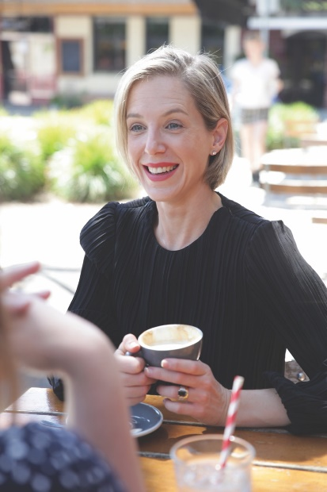
Almost 39 percent of first-time strokes in Australia strike people aged between 20 and 64 years. Around 124,000 Australians in this age group are living with the impact of stroke.
With the support of a grant from the National Disability Insurance Agency (NDIA), Stroke Foundation commenced a three-year co-designed Young Stroke Project to deliver tailored information to working-age survivors of stroke, aged 18–65 and their support crew. Launching with workshops, podcasts and videos.
The project includes engaging with diverse communities, with a focus on Aboriginal and Torres Strait Islander and LGBTQI+ communities.

Case Study: Peacock Family
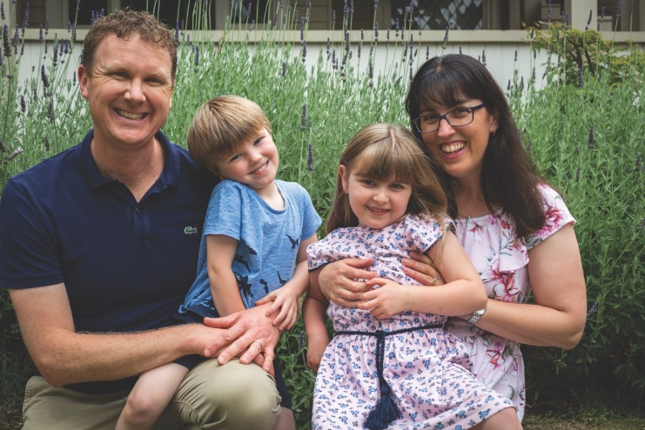

Georgia was just 11 months old when she suffered a stroke and lost all movement on her right-hand side.
Following her stroke, Georgia spent six weeks in intensive care and more than two months on a hospital ward. Georgia’s parents, Tony and Kim Peacock, were by their daughters’ side 24/7.
With backgrounds in health care, Tony and Kim were aware of the importance of early rehabilitation. Within eight weeks Georgia began speech therapy, occupational therapy, physiotherapy and hydrotherapy. Georgia responded well to her early rehab.
Although positive gains were being made, something was missing. Georgia’s parents wished they could speak to someone who had been in their shoes. Unfortunately, there was very little information available. When Stroke Foundation launched Our Family’s Stroke Journey in 2020, the resource filled this gap, providing examples of recovery journeys of other children, and their families, impacted by stroke.
“These stories provide hope that good outcomes are possible at a time when everything feels overwhelming. It provides the comfort you are not alone.”
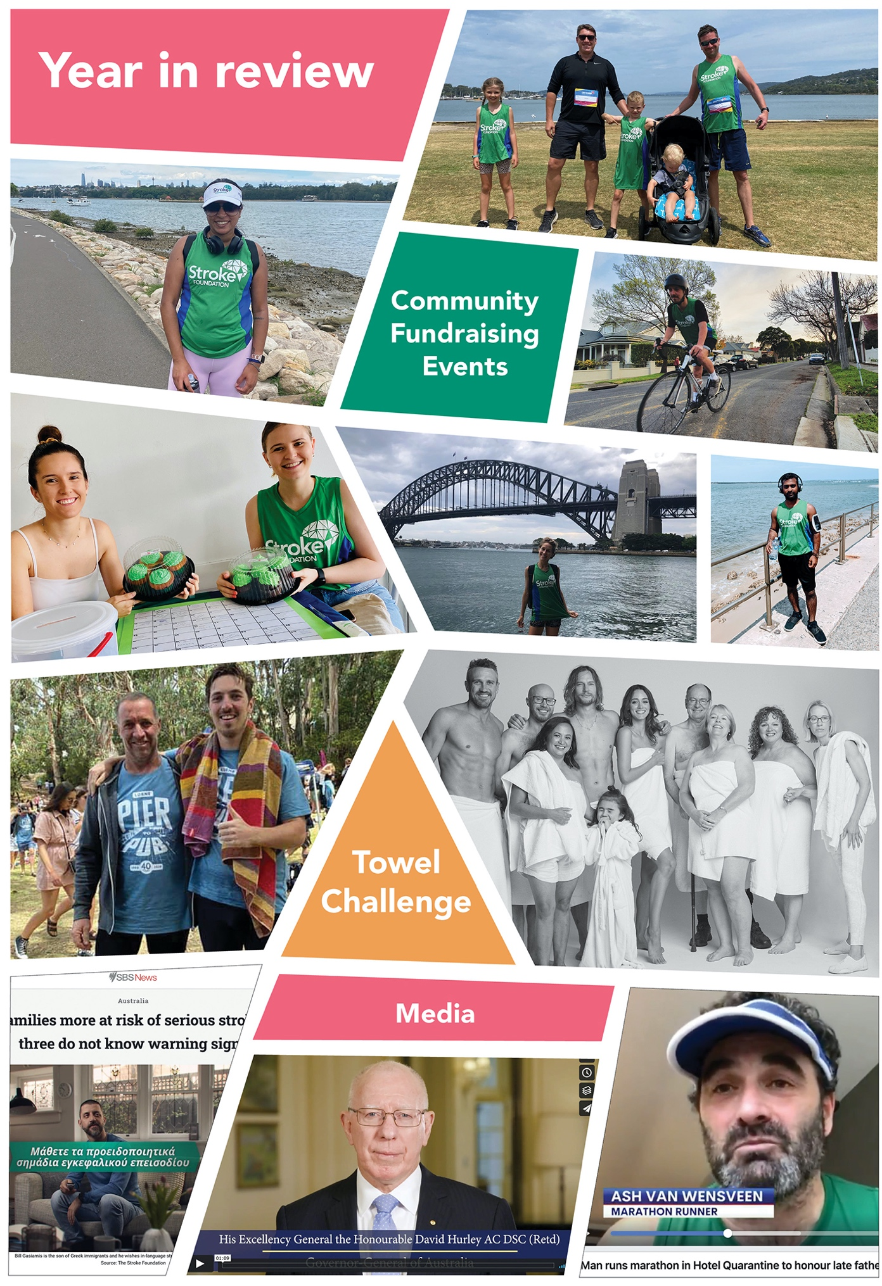
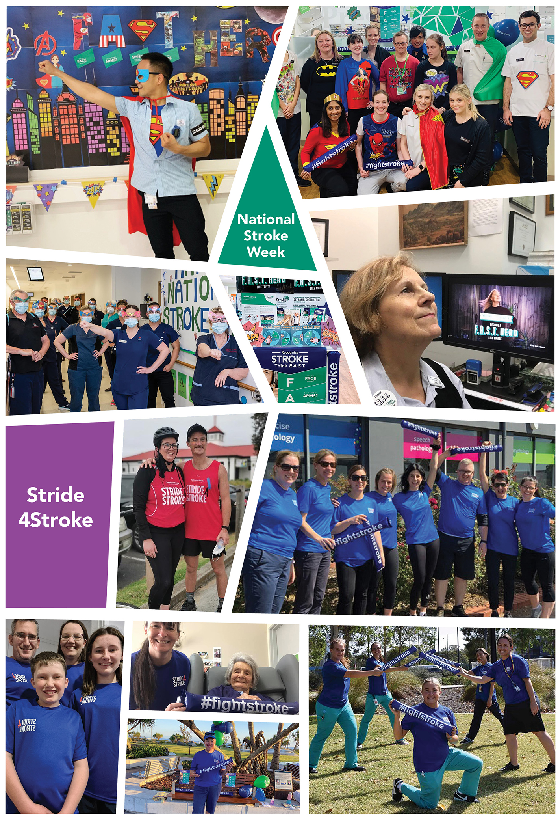

Goal 4: Champion research in stroke
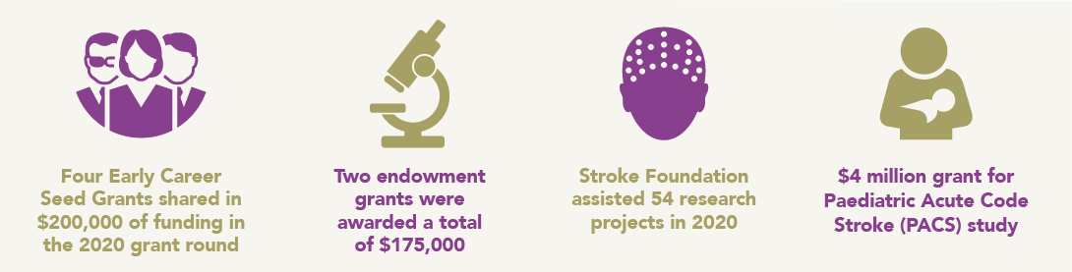
With the rate of stroke increasing among younger adults (35 – 54 years*) and emerging international studies finding there may be a link between coronavirus (COVID-19) and increased stroke risk, research is needed now – more than ever – to help people with stroke survive and thrive.
* Deloitte Access Economics, No Postcode Untouched 2020 (November 2020)

But it takes time, dedication and a great deal of funding. Stroke Foundation is supporting researchers to bring their big ideas to life and nurturing their potential to save lives, reduce disability and benefit generations to come.
With the help of our generous donors, Stroke Foundation has continued to invest in research which has the potential to generate new knowledge aimed at driving improvements in stroke prevention, treatment and care.

Research Grants
Six research projects shared in $375,000 of funding this year through Stroke Foundation’s grant round. A number of the research trials are investigating the role of telehealth to better understand how to maximise its benefits in health care delivery, particularly for people based in rural and regional areas with limited access to therapists.
Early Career Seed Grants ($50,000) recipients:
- Lauren Christie, Nursing Research Institute (NRI) – St Vincent’s Health Network, Sydney and Australian Catholic University. ReCITE (Remote Constraint Induced Therapy of the upper Extremity). Study investigating telehealth as an alternative to face-to-face therapy targeting arm weakness after stroke.
- Dr Caroline Baker, La Trobe University.
Optimising mood and wellbeing with aphasia after stroke: a feasibility study of Prevention Intervention and Support in Mental health (PRISM) via telerehabilitation.
- Dr Heidi Janssen, Hunter New England Local Health District. Yarning up After Stroke – working with Aboriginal and Torres Strait Islander communities and people living with stroke to take a yarning-based tool for self-management of recovery.
- Dr Di Marsden, Hunter New England Local Health District. Let’s have a yarn about our bladder – partnering with Aboriginal people to implement stroke guideline-recommended urinary continence and lower urinary tract symptom care that is culturally appropriate and safe.

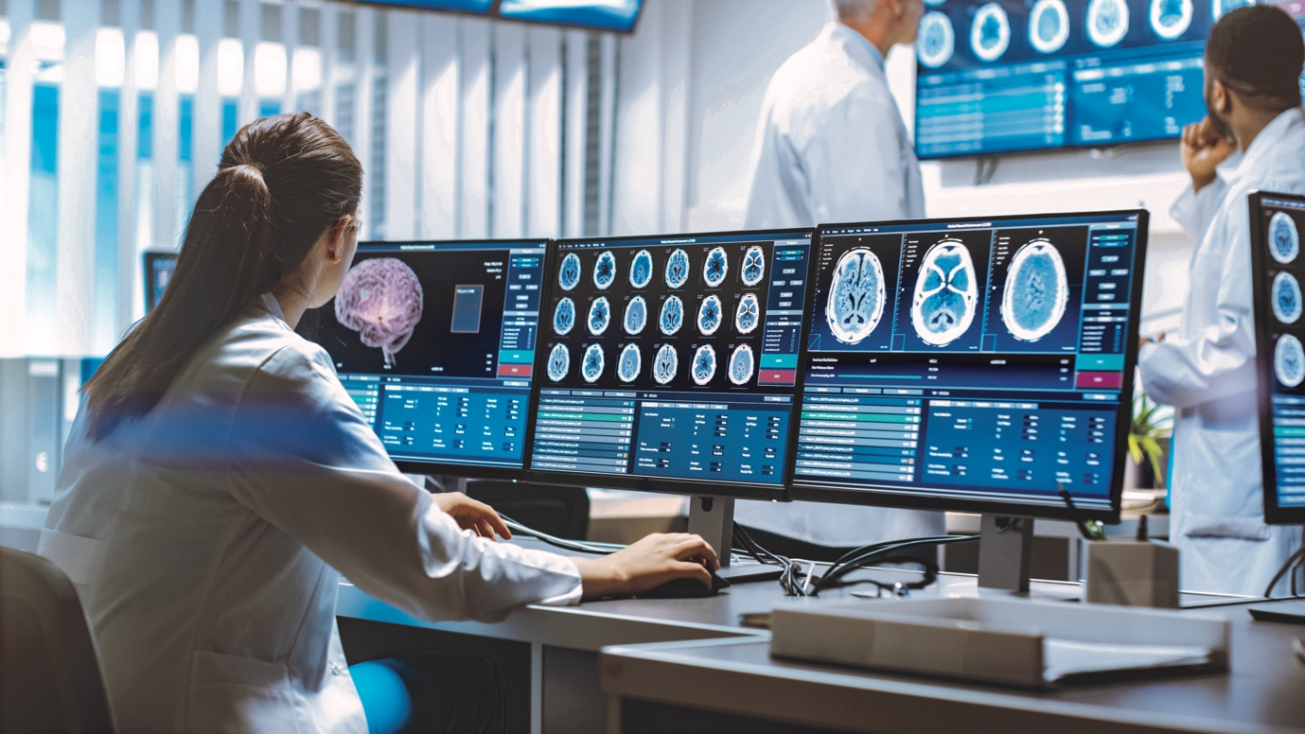
Stroke Foundation has assisted 54 research projects to recruit participants in 2020. This highlights trust and strong connections with survivors of stroke and research communities.

Endowment grants
Endowment grants were awarded in this research grant round. These grants were made possible through the generous donations from families personally impacted by stroke who decided to leave a lasting legacy. Endowment grants are investments in dedicated areas of research determined by the donors in consultation with Stroke Foundation.

Nancy & Vic Allen Stroke Prevention Memorial Fund
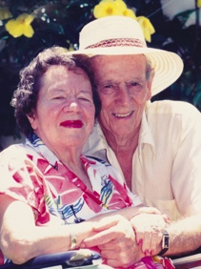
Professor Coralie English, University of Newcastle. i-REBOUND after stroke – development of an online program to prevent recurrent stroke and support long-term health and wellbeing. Professor English and her team will develop an online exercise and healthy eating program, specifically designed in partnership with and for, survivors of stroke.

Tim Glendinning Memorial Fund for Young Adult Stroke
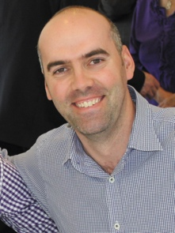
Dr Alyna Turner, Deakin University. Resuming Employment after Stroke: Enhancement through Telecoordination – RESET Rural Expansion. Dr Turner’s project will utilise telehealth to identify barriers in returning to work for people with stroke in rural and regional areas.

Gavin Paul Bennier Memorial Research Fund
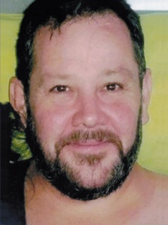
Awarded to Professor Vincent Thijs from the Florey Institute of Neuroscience and Mental Health in 2019. Work continues on Professor Thijs’ project to investigate the prevalence of the rare brain disorder in young survivors of stroke.

Case Study: Mark Mackay
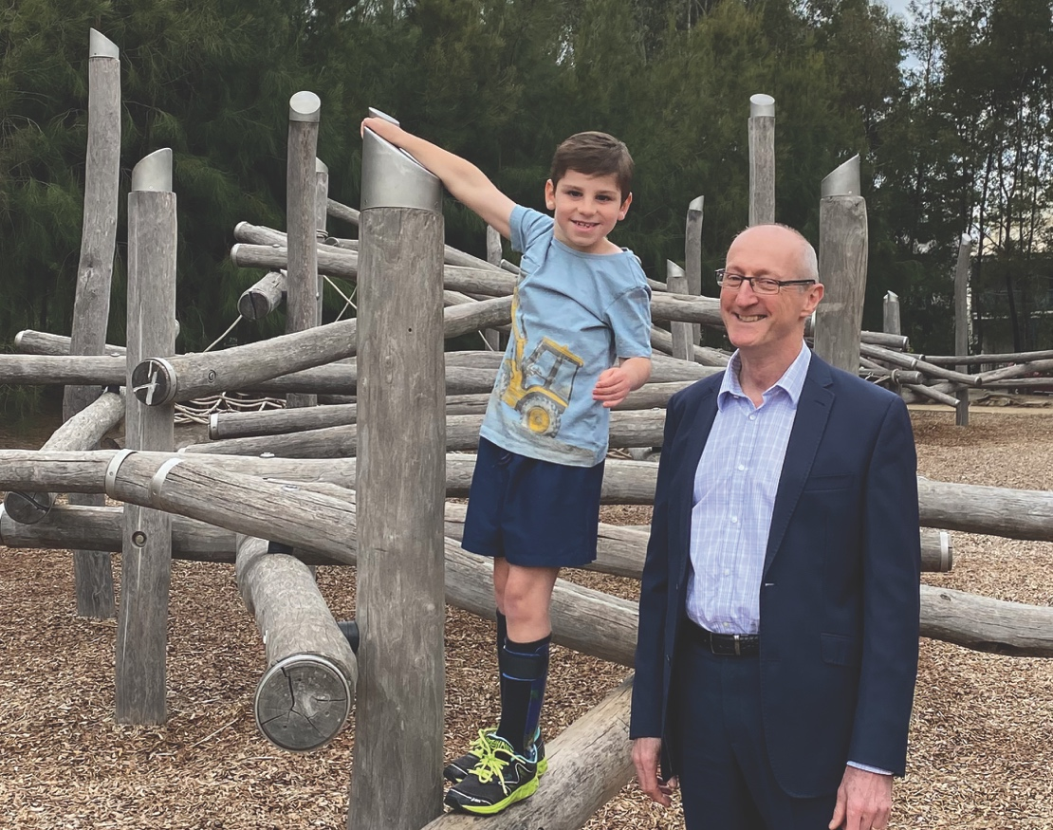

Associate Professor Mark Mackay is the key voice in paediatric stroke in Australia. Assoc Prof. Mackay’s work is changing the lives of our littlest survivors of stroke.
In 2020, the Federal Government announced a $4 million grant for the Paediatric Acute Code Stroke (PACS) study, of which Assoc Prof. Mackay is the chief investigator.
It is a landmark study which aims to transform the care of Australian children with stroke by dramatically decreasing time to diagnosis and increasing the number of children receiving emergency stroke treatments more commonly used for adults.
This research has the potential to change the way stroke is treated in children nationally for generations to come.
Assoc Prof. Mackay is a senior neurologist at the Royal Children’s Hospital Melbourne and a Clinician-Scientist Research Fellow at the Murdoch Children’s Research Institute and a member of Stroke Foundation’s Clinical Council.
“I am proud to be involved in this research. It is an exciting and much needed step forward in helping our littlest patients with stroke survive, grow and thrive.”

Goal 5: Grow our impact and manage our charity effectively and efficiently
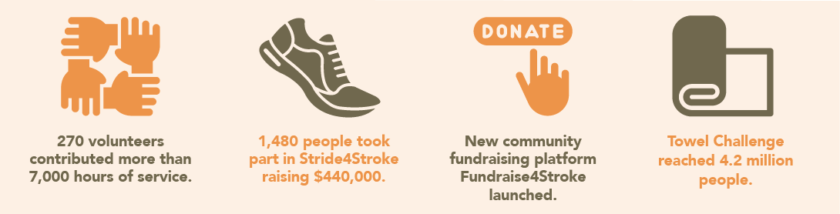
In 2020 our amazing supporters and volunteers joined us, standing alongside survivors of stroke, their families, carers, dedicated health professionals and researchers to provide their time, expertise, and financial support.

Together with the experiences of our community and evidence-based research we will continue our important work and grow our impact to prevent, treat and beat stroke. We thank everyone in our incredible stroke community for their tireless efforts in supporting our work.

Volunteers
Stroke Foundation volunteers contributed more than 7,000 hours in 2020. Our volunteer workforce continued to show their dedication and commitment despite an ever-changing environment.
StrokeSafe Speakers are now presenting sessions online where required, media and public affairs volunteers are working remotely, the Board and all committees and councils have been conducting meetings online. We could not achieve all that we do without our volunteers.

Governance
Since its incorporation in 1996, Stroke Foundation has been governed by an independent Board of Directors. The Board is supported by the expertise of leading health professionals in stroke and is informed by survivors of stroke, carers, and their families.
Stroke Foundation’s corporate performance is overseen by the Audit, Finance, Investment and Risk Committee and the Governance and Nominations Committee. An Endowment Fund Management Committee is also in place.

The economic impact of stroke report
Stroke Foundation commissioned Deloitte Access Economics to deliver The economic impact of stroke in Australia, 2020, quantifying the impact of stroke. Using financial modelling the report looks at direct health system costs as well as the broader impact of short and long-term disability on the community. It also provides roadmaps for focus and investment to change the course of this disease, highlighting the opportunity and value in preventing stroke and improving access to stroke treatment.
With an estimated 27,428 Australians experiencing stroke for the first time in their lives in 2020, and an estimated 445,087 survivors of stroke living in the community, the economic cost of stroke exceeded $6.2 billion. A further $26 billion in lost wellbeing due to short and long-term disability, and premature death.
Reducing uncontrolled high blood pressure and improving access to stroke treatment and care could equate to savings of $179 million over five years in economic costs and $2.4 billion in reduced mortality and improved wellbeing annually.
His Excellency General the Honourable David Hurley AC DSC (Retd), Governor General and Stroke Foundation Patron, launched The economic impact of stroke in Australia, 2020 and No Postcode Untouched reports at a virtual webinar in November 2020.
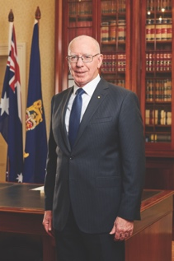

Tasmanian Iconic Walks
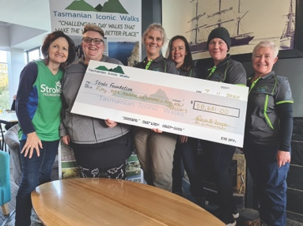
The 3rd Tasmanian Iconic Walks, organised by Jo Cordell Cooper and the TIW committee, saw over 80 participants trek from Tasman Arch to Fortescue Bay: raising more than $69,000.

Stride4Stroke
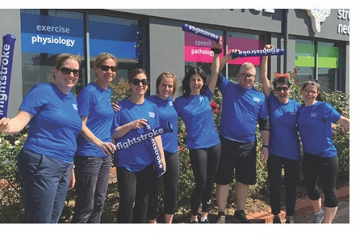
1,480 inspiring individuals set an activity goal in November and covered 121,800 kms to raise a record breaking $440,000.

Fundraise4Stroke
Stroke Foundation launched our new community fundraising platform Fundraise4Stroke.org.au
Get involved #together4stroke
#celebrate4stroke
#active4stroke
#play4stroke

Towel Challenge
Australian Survivor All-Star contestants David Genat and Lee Carseldine approached Stroke Foundation with an idea to honour Lee’s mum Elizabeth.
“Hopefully out of something so tragic as losing my mum, something good can happen.”
The ask was simple, get a towel on for a good cause. Donate or grab a towel and take a photo, post it on Instagram with #towelchallenge. Participants could also nominate their friends and family to join the challenge. The campaign saw survivors of stroke and Australian Survivor contestants get involved to raise funds and awareness of stroke. The Towel Challenge campaign raised over $47,000 and reached an incredible 4.2 million people.

Case Study: Jan Lalor
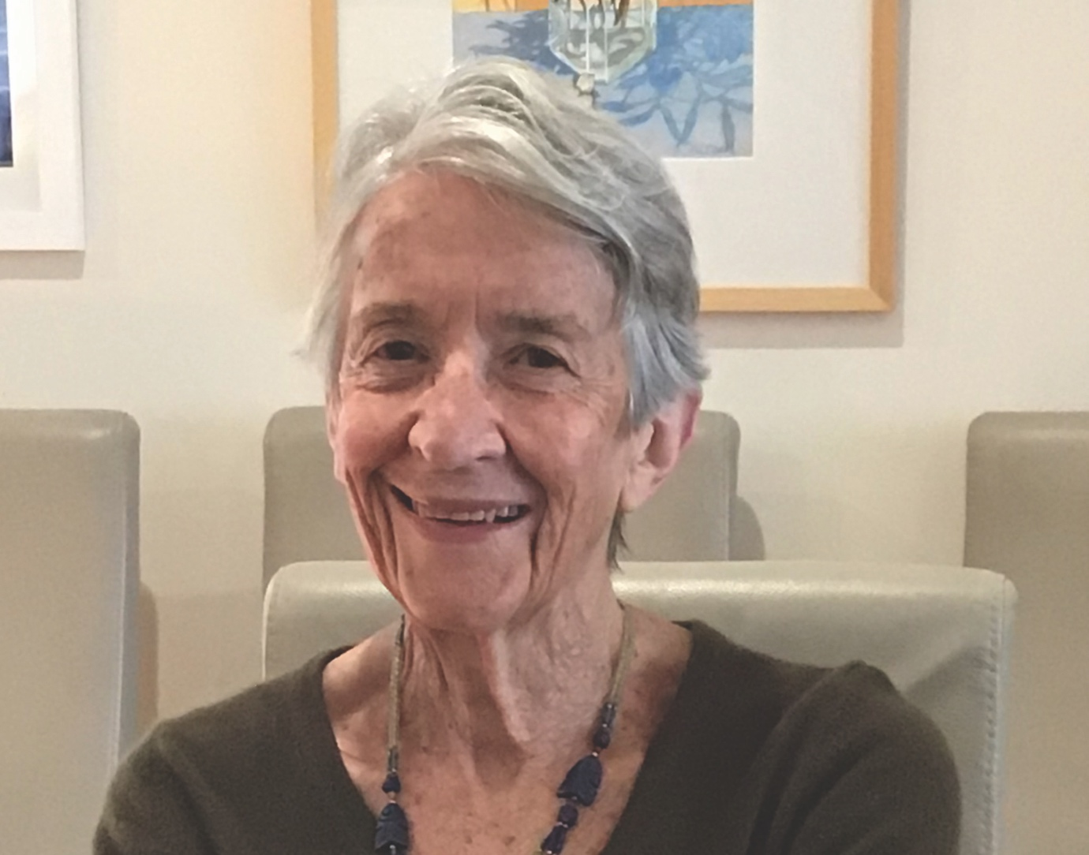

Jan Lalor is an unsung hero of stroke, tirelessly volunteering her time at Stroke Foundation for more than 15 years.
In 2020, Jan received the Stroke Awards Volunteer of the Year award for her incredible generosity and dedication.
Over the years, Jan has performed many duties to help reduce the impact of stroke on the community including packing and sending thousands of key resources to hospitals, doctors’ clinics, pharmacies, community groups, survivors of stroke and the general public.
“I have always enjoyed volunteering and I have learnt so much from spending time with people who have had stroke and become volunteers themselves.”

Financials
The operating result for the 2020 year was a net surplus of $2.0m.
The year was dominated by the impact of the COVID-19 pandemic. The organisation’s preparedness for such an event was severely tested but proven effective as operational activity was quickly moved to a remote working environment.
Maintaining the health and wellbeing of our workforce, volunteers and the stroke community was our top priority as we adjusted marketing and consumer engagement plans to respond to COVID-19 related restrictions on public movement.
Initial forecasts of decreased revenue proved accurate in appeals (although revenue reductions were not as large as initially estimated), however, this was partially alleviated by the government JobKeeper subsidy (six months only). Ultimately, revenue growth was achieved through the generosity of various benefactors via increased gifts in wills received.
Highlights:
- Secured an MRFF Grant of $4.0m over 4 years to deliver the Australian Paediatric Acute Code Stroke (PACS) study in partnership with the Murdoch Children’s Research Institute.
- Secured $1.1m funding over four years for F.A.S.T. (Face. Arms. Speech. Time.), a public awareness and community education campaign which aims to teach people the most common signs of stroke.
- A third endowment fund – ‘Nancy & Vic Allen Stroke Prevention Memorial Fund Grant’ was launched dedicated to stroke prevention.

Program support 2020
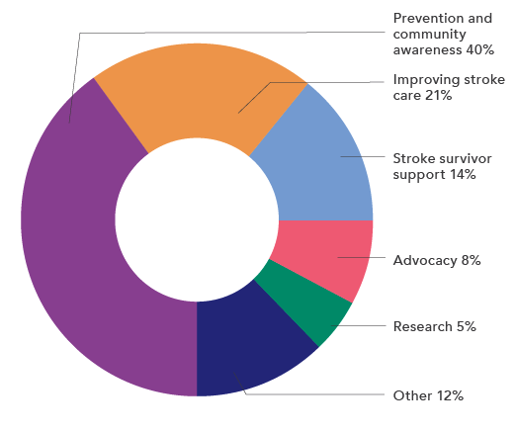

Sources of income 2020: $19.7m
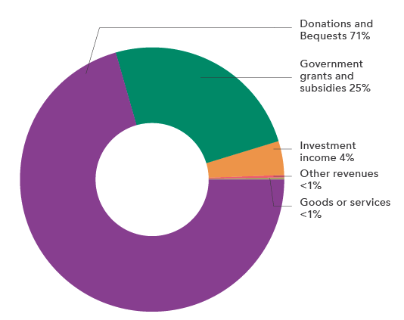
Donations and Bequests 2020: $13.9m
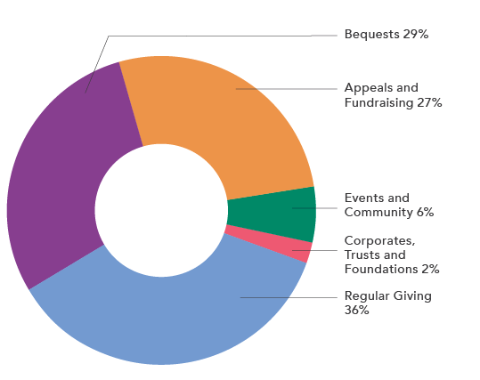

Team stroke
As Australia’s only national stroke charity, we are privileged to have many talented, passionate and generous supporters standing alongside us – and we are immensely grateful.

We thank our:
Patrons who inspire us.
Ambassadors who champion our cause.
Board members who lead and guide us.
Clinical Council who ensure our health professional resources, guidelines and services are evidence-based.
Research Advisory Committee who guide and support our research program.
Consumer Council who inform and guide our decisions through their lived experience of stroke.
Governments who partner with us to ensure a healthier Australia and better outcomes for people with stroke.
Health services who partner with us to provide access to evidence-based stroke treatment, care and rehabilitation services.
Health professionals who give their time, expertise and commitment to quality stroke treatment and care.
Our employees who show their passion, commitment and compassion every day in delivering our vision and mission.
Our amazing volunteers who give their time, energy and expertise.
Supporters who stand alongside us, survivors of stroke and their families, health professionals and researchers.
Those impacted by stroke and their families who inspire and drive us to deliver on our mission every day.
We express our heartfelt thanks to you all.
Thank you for joining with us to prevent, treat and beat stroke.

Stroke Award Winners
We congratulate and honour those who continually go above and beyond to make a positive difference for stroke in Australia.

President’s Achievement Award
Associate Professor Tim Kleinig (SA)
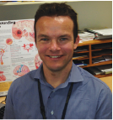
For a strong commitment to excellence in stroke treatment and care and establishing successful clinical stroke research programs.

Creative Award – proudly sponsored by Marmalade Melbourne
Tony Finneran (NSW)
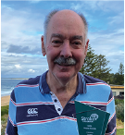
For writing six pictorial history books on Australia’s bus and coach industry. The books have raised more than $38,000 for Stroke Foundation.

Fundraiser of the Year Award – proudly sponsored by Precision Group
Matt Picone (TAS)
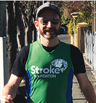
For fulfilling a goal to conquer a half marathon shortly after a stroke and raising $24,000 in the process.

Courage Award – proudly sponsored by Medtronic
Tracey Gibb (SA)
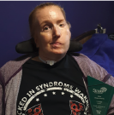
For tenacity and resilience in her recovery from stroke. Tracey cannot speak or move, however she has learnt other ways for her voice to be heard. Tracey has educated the community on stroke and communication.

Volunteer of the Year Award – proudly sponsored by NAB Community
Jan Lalor (VIC)
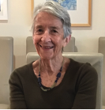
For volunteering at Stroke Foundation for 15 years, packing and sending thousands of resources to hospitals, doctors’ clinics, pharmacies, community groups, survivors of stroke and the public.

Improving Life after Stroke Award – proudly sponsored by Australian Physiotherapy Association
Ron and Marge Townrow (VIC)
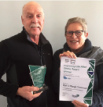
For their dedication to raising awareness of stroke through various volunteer roles and helping survivors of stroke re-enter the community.

Thank you to all our supporters
Patron-in-Chief
His Excellency General
the Honourable David
Hurley AC DSC (Retd)
Patron
Mr David Brownbill AM

Patron
Sir Gustav Nossal AC CBE

Patron
Lady Marigold Southey AC

Ambassador
General the Honourable
Sir Peter Cosgrove
AK CVO MC (Retd)

President
Professor James Angus AO

Vice President
Mr Christopher Edwards

Directors
Professor Amanda Thrift
Professor Bruce Campbell
Ms Jennifer Muller PSM
Councillor Karen Vernon
Ms Sally Bateman
Mr Christopher Edwards
Mr Andrew Matthews
Mr James Stanistreet
(resigned 17 July 2020)
Mr Christopher Nunn
Ms Janice Thomas
Professor Linda Krisjanson AO
(appointed 29 October 2020)

Clinical Council
Professor Bruce Campbell,
Chair
Dr Rohan Grimley
Professor Susan Hillier
Dr Claire Muller
Associate Professor
Erin Godecke
Ms Skye Coote
Dr Timothy Ang
Professor Natasha Lannin
Professor Steven Faux
Associate Professor Seana Gall
Associate Professor
Mark Mackay
Associate Professor
Martin Jude OAM

Health Promotion Advisory
Committee
Associate Professor Seana Gall,
Chair
Dr Siobhan Hickling
Professor Corneel Vandelanotte
Professor David Thomas
Professor Mark Harris
Professor Simone Pettigrew
Mr Nic Stephen

Consumer Council
Ms Jennifer Muller PSM, Chair
Ms Julie Collins
Ms Nadia Moffatt OAM
Mr Kevin English
Mr Tony Finneran
Mr Tony Rolfe
Ms Saran Chamberlain
Mr Nic Stephen
(Deputy Chair)
Ms Kim Beesley
(appointed 29 October 2020)
Ms Jasmina Behlic
(appointed 29 October 2020)

Audit, Finance, Investment
and Risk Committee
Mr Christopher Edwards, Chair
Mr Peter Fekete
Mr Alan Lahiff
Mr Andrew Matthews
Mr Christopher Nunn

Company Secretary
Mr John Buchanan
(resigned 5 May 2020)
Mr Matthew Oakey
(appointed 6 May 2020)

Governance and
Nominations Committee
Councillor Karen Vernon, Chair
Professor James Angus AO
Ms Sally Bateman
Mr Christopher Edwards
Professor Linda Krisjanson AO
(appointed 29 October 2020)

Research Advisory
Committee
Professor Amanda Thrift, Chair
Ms Brenda Booth OAM
Professor Simon Koblar
Dr Caleb Ferguson
Associate Professor
Emma Power
Professor Ian Kneebone
Associate Professor
Nadine Andrew
Professor Mark Nelson
Dr Eleanor Horton
Professor Sandra Eades

Endowment Fund
Management Committee
Mr Andrew Matthews, Chair
Professor Amanda Thrift
Professor Coralie English
Mrs Lynette Glendinning
Ms Janice Thomas (appointed
25 June 2020)
Ms Ava-May Morgan (resigned
25 September 2020)
Patron-in-Chief
His Excellency General
the Honourable David
Hurley AC DSC (Retd)
Patron
Mr David Brownbill AM
Patron
Sir Gustav Nossal AC CBE
Patron
Lady Marigold Southey AC
Ambassador
General the Honourable
Sir Peter Cosgrove
AK CVO MC (Retd)

Auditors
Pitcher Partners

Honorary Life Members
Mr Paul Leeds
Mr Michael Hill
Mr David Brownbill AM
Sir Gustav Nossal AC CBE
Lady Marigold Southey AC
Professor Christopher Bladin
Professor Christopher Levi
Dr John Lill OAM
Professor Stephen Davis AM
Mr William Forrest AM
Mr Andrew Buckle OAM
Professor Richard Lindley
Professor Richard Larkins AO
Mr Peter Mitchell AM
We remember and
acknowledge Mr Peter
Mitchell AM who sadly
passed away in 2020.
Professor Julie Bernhardt AM
Dr Erin Lalor AM
Professor Geoffrey Donnan AO

  - Major partners

  - Website partners

  - Supporting partners

AllClear Travel Insurance
Arnold Bloch Leibler
Australian Physiotherapy Association
Bell Charitable Fund
Blue Label
Bristol-Myers Squibb & Pfizer Alliance
Campari Australia
Collier Charitable Fund
Corrs Chambers Westgarth
The Elizabeth & Barry Davies Charitable Foundation
Fairbrother Foundation
Fired Up Group
J.J Richards Waste & Recycling
LaTrobe Valley Bus Lines
Marmalade Melbourne
The Minyaka Fund and Weston Street United Masonic Fund, charitable fund accounts of the Lord Mayor’s Charitable Foundation
NAB Community
Newcastle Permanent Charitable Foundation
O’Brien Accountants and Advisors
Omron
OzCad
Popsockets
RMBL Investments Pty Ltd
Russell & George
Superfluid
Wisewould Mahony
Australian Government
National Disability Insurance Agency (NDIA)
Information, Linkages and Capacity Building (ILC)
Department of Industry, Innovation and Science – Medical Research Future Fund (MRFF) Emerging Priorities and Consumer Driven Research (EPCDR) Initiative
MRFF Cardiovascular Health Mission
Department of Social Services

State Government
Australian Capital Territory Government
Queensland Health
Tasmanian Department of Health and Human Services
Western Australian Department of Health
New South Wales Department of Health

Health and charity partners
Cancer Council Victoria
Cochrane Australia
Diabetes Australia (Queensland)
Murdoch Children’s Research Institute
National Heart Foundation

Key Alliances
Australian Chronic Disease Prevention Alliance (ACDPA)
Australian Living Evidence Consortium
Australian Stroke Alliance
Australian Stroke Coalition
World Stroke Organization

Gifts in Wills Supporters
We were very grateful to receive generous gifts from the following wonderful supporters who thoughtfully included a gift in their Will to Stroke Foundation.

Jeanette Alfredson
Maureen Anderson
Mary Austin
Pauline Barritt
Elaine Bobbin
Anna Maria Bonanno
Nola Bren
Leonard Bridges
Robert Burden
Helen Burgess
Clarence Burke
Mary Davie
Betty Dickinson
Robert Donnan
Maria Draho
Elaine Dray
The Late James Fairfax AC
George Fitchie
Keith Fountain
Barbara Fuller-Quinn
Heidi Goldstein
Francis Goudge
Nancy Graeme-Evans
Richard Graham
Cecelia Gurowski
Rosemary Hope
Feryne Hunter
Louise Kilpatrick
Norma Lang
Mildred Lapthorne
Barbara Le Gros
Robert Lettich
Maureen Lister
Raymond Maher
Heinz Mahl
Joan March
Mrs Matheson
Leslie Maurer
Valerie McDonald
Ian McLean
Bethel Monks
Joy Moore
Margery Moore
Joan Neumann
Shirley Nicholas
Maxwell Parkinson
Clifford Priestley
Beryl Raymer
Allan Rowling
Anna Marie Schaepman
Arthur Sherriff
Dorothy Slaney
John Stackpool
Alan Steele
Valerie Stockwell
Gertrude Tatzel
Doreen Taylor
Valerie Thorburn
Nancy Valentine
Elsie Walker
Gregory Walker
Donald Watson
Peter Webb
Reta Williams
Joan Willis
Eleanor Wood

Major Donors
Mr Michael Ahrens
Mr & Mrs Geoff & Robin Aubourg
Mr & Mrs Leo & Ann Browne
Mr & Mrs Ian & Barbara Butler
Mr Neville Castles
The Ronald Alan Curry Trust
Miss Jane Farrell
Dianne & Giorgio Gjergja
Dr Michael Gronow
Mr & Mrs William & Alison Hayward
The Halifax Foundation
Dr Margaret Harding
The Kerridge Foundation
King Family Foundation Ltd
Ms Robin Manning
Mr Robin McCosker
Mostyn Family Foundation
Mrs Sylvia Miller
Graham & Pam Nock Foundation
Mr Olaf O’Duill
Mr & Mrs David & Glenys Overton
Annie & John Paterson Foundation
Miss Jane Rich
Mr James Rolfe
Ms Jill Ross-Perrier
The Russell Foundation Pty Ltd
Mrs Dianne Shakespeare
Mrs R Slaughter
Lady Marigold Southey AC
The Sun Foundation Pty Ltd
Ms Jennifer Tatchell
Mr Gregory Vaughan
Wheatley Family Foundation
Mrs Jean Williamson
Mr & Mrs Leo & Ann Browne

Counterstroke Golf Classic Committee
Dee Clements (Co-Chair)
Chris Reilly (Co-Chair)
Helen Angus
Libby Cotton
Ross Eddy
Caroline Ennels
Ian Gardner
Graeme Hall

Major Community Fundraisers
Tasmania Iconic Walks
Committee
Jo Cordell-Cooper
Marg Marshall
Melinda Williams
Linda Britts
Caroline Gray
Rani Milne

Team Motivational Sneakers
Matt Picone (Captain)
Andy Cunningham
Sam Webster
Massimo Mele

Ash & Adam Running in Quarantine
Adam Hills
Ash Van Wensveen

Towel Challenge
Lee Carseldine
David Genat

Kuts for Kev
Jack Catswood-Pyper

Stride4Stroke
Team G Love
Misha Cadzow (Captain)
Mieke Franzen
Jamie Samuels
Jeremy Cadzow
Emma Hughes
Hayley Gamblin
Tim Franzen
Tom Samuels
Xanthe Franzen
Tracey Sinay

Little Stroke Warriors
Dee Banks (Captain)
Deb Mcpherson
Amy Osborne
Hayley Newberry
Robyn Virgona
Jessica Curtis
Sandy Hoskin
Jodie Ratcliff
Carolyn Harrison
Kiara Maieron
Lydia Whiteside
Jasmine Hodge
Dylan Sloman
Tricia Brown
Kylie Facer
Ellen Maieron
Renee Facer
Judy Anshaw
Mathew Facer
Jess Rutherford
Linda Wickes
Natalie Dunn
Tye Hambleton
Janene Facer
Nicola Zammit
Janette Grant

Team Regis
Stan Veloutsos (Captain)
Yvonne Abell
Sophie Andritsos
Thanushi Ariyasiri
Helen Bagnall
Kerrin Barassi
Kellie Barbaro
Geraldine Beagan
Amanda Brabon
David Buthlay
Soong Kiang Chng
Marion Cole
Roslyn Cooper
Helen Davey
Fiona de Vries
Jessica Feild
Carol Fox
Anna Franklin
Jacinta Goldsack
Sawitree Hasiri
Tracey Hollywood
Jessica Hood
Renee Horvat
Przemyslaw Jozwiak
Sally Kalaiarasu
Gael Keillor
Sayana Kodippily
Alexi Lawes
Audrey Lee
Hazel Mango
Natalie Matthews
Annie McMullan
Colleen Milan
Kayla Miller
Rachel Morel
Fahad Muhammad
Nikita Murphy
Mazino Onibere
Irene Pacheco
Akriti Pant
Ketan Parmar
Nishant Patel
Tarpan Patel
Dinesh Perera
Leah Price
Olivia Rattray-Wood
Carolyn Russell
Ranjit S Sanghe
Malika Senaratna
Liz Shaw
Melissa Shaw
Scott Sherratt
Ricky Solanky
Sam Somarathne
Stan Veloutsos
Nicola Watt
Mitch Webster
Ranjan Weerasinghe
Meg Willis
Chloe Zinner

Training with mates
Daniel Maitland (Captain)
Sophie Amerena
Phil Carew
Eliza Crane
Stuart Davies
Connor Downie
Will & Emile
Malcolm Gamble
Brooke Goulding
Rhian Graco
Amy Lennon
Wes Lian
Daniel Maitland
Kirby Marks
Sam McBain
Joel Mckee
Mikaela Morgan
Bec Neaves
Vikki Octigan
Jackson Peet
Stephanie Peet
Joshua Rochford
Ciara Scott
Paul Silberer
Michael Skaftouros
Natasha Sneddon
Eleyne Spencer
Mitchell Stoneman
Jorja Strack
Sophie Virtue
Meaghan Zervaas

Contact us
- 1300 194 196
- strokefoundation.org.au
- /strokefoundation
- @strokefdn
- @strokefdn

How to get more involved
- Give time – become a volunteer.
- Raise funds – donate or hold a fundraising event.
- Speak up – join our advocacy team.
- Leave a lasting legacy – include a gift in your Will.
- Know your numbers – check your health regularly.
- Stay informed – keep up-to-date and share our message.

