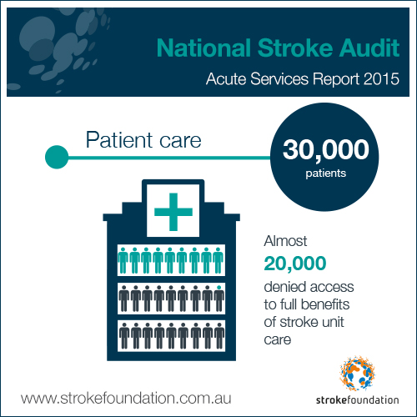
2016 Canberra Summit – Fight Stroke talks to Parliament!

Hashtag it: #fightstroke #gapsincare #auspol #aushealth

Stroke Foundation on Facebook , Twitter , Instagram
Link to www.strokefoundation.com.au

Facebook it:
Simply click here and share our call for action directly from the Fight Stroke Facebook page
Tweet it:
Cut and paste and voila……

Some facts:
In 2016 11,000+ Aussies will die from stroke, most AU hospitals can’t give best treatment http://bit.ly/1NmIdN2 #fightstroke
Only 1 complete stroke centre operating in Australia! There should be 1 in each state http://bit.ly/1NmIdN2 #fightstroke
Survivors take #fightstroke to Canberra to ask – Why all Aussies can’t access best stroke treatment. http://bit.ly/1NmIdN2
Some emotion:
You think your family deserves the best stroke care? Why is only 1 hospital in AU set up to deliver it? http://bit.ly/1NmIdN2 #fightstroke
Stroke kills more woman than breast cancer, only 1 hospital in AU ready to deliver you best stroke care http://bit.ly/1NmIdN2 #fightstroke
Stroke kills more men than prostate cancer, only 1 hospital in AU ready to deliver you best stroke care http://bit.ly/1NmIdN2 #fightstroke
Where you live should not decide if you live after stroke http://bit.ly/1NmIdN2 #fightstroke
To ask:
A tragedy that only small % of Aust #stroke patients get access to latest treatments & innovation - we know it save lives says @SharonMG311
Challenge to @TurnbullMalcolm Govt: Stand up for stroke address the #gapsincare http://bit.ly/1NmIdN2 #fightstroke #auspol #aushealth
Will @billshortenmp back our call for more funding to address #gapsincare http://bit.ly/1NmIdN2 #fightstroke #auspol #aushealth
Will @CatherineKingMP back our call for more funding to address #gapsincare http://bit.ly/1NmIdN2 #fightstroke #auspol #aushealth
Why are 4 in 10 stroke patients denied best treatment each year @sussanley? http://bit.ly/1NmIdN2 #fightstroke #auspol #aushealth
Why is our health system ill-equipped to handle stroke epidemic? @TurnbullMalcolm @sussanley http://bit.ly/1NmIdN2 #fightstroke #auspol
Why can’t we access aus made technology? Other countries are - to save lives @TurnbullMalcolm http://bit.ly/1NmIdN2 #fightstroke #auspol

