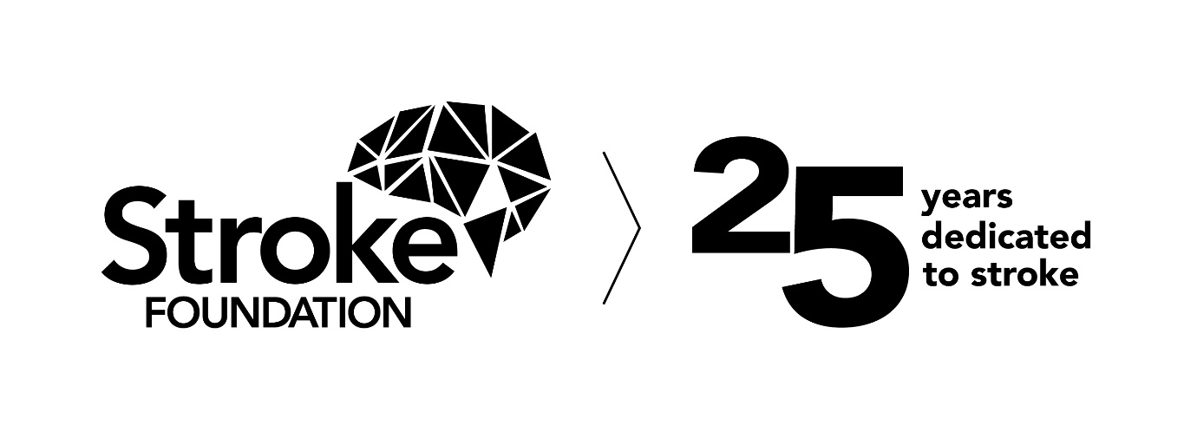
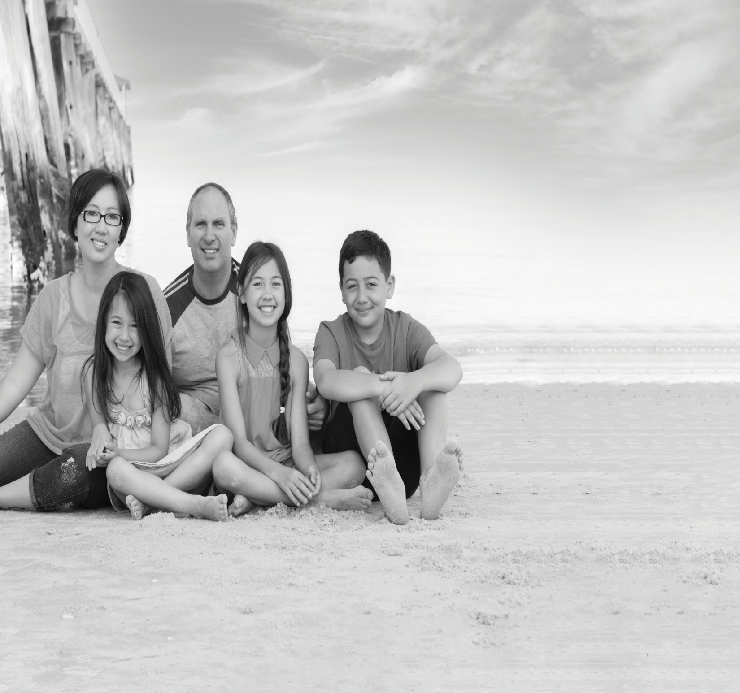
Annual Review 2021

Survivor of stroke, Saran Chamberlain (far left) and her family.

strokefoundation.org.au

Chief Executive Officer's message

The tenacity, perseverance, and determination of Australia’s stroke community continued to be tested by the COVID-19 pandemic throughout 2021.
I don’t think I have ever been prouder of the way our team and our community came together, united by stroke, to rise to the challenge.
A highlight was welcoming our new President, Emeritus Professor Linda Kristjanson AO. It has been wonderful to see Linda’s vast experience already begin to benefit Stroke Foundation.
Linda took the reins from the esteemed Professor James Angus AO, whose contribution over the past six years has seen significant advances including Australia’s first stroke ambulance and a world first “living” clinical guidelines model for stroke. We wish him the very best in his new role as Lieutenant-Governor of Victoria.
Our 2021 National Stroke Week was COVID-impacted, but under the banner ‘united by stroke’ we embraced a virtual launch of a new resource for Aboriginal and Torres Strait Islander peoples – Our Stroke Journey.
Lockdowns meant the only place we could physically host the launch of Our Stroke Journey was Perth. It gave us a wonderful opportunity to highlight our West Australian team and celebrate our partnerships with Aboriginal and Torres Strait Islander peoples, healthcare workers, and government sectors.
I continued to be in awe of the selfless contributions of our fundraisers this year. Thank you to everyone who supported us.
A special mention to Tommy Quick, who began an epic fundraising adventure in June – cycling to the four furthest points of Australia! He was approaching Adelaide when he was hit by a car in a terrible accident. Despite significant injuries Tommy never stopped updating his supporters. This remarkable man is determined to finish his adventure when he can.
It is a lesson in never giving up, and one our Stroke Foundation team will have front of mind as we embark on our new strategic plan in 2022. Our vision is ambitious – we want a world free from disability and suffering caused by stroke.
As a focused, impact-driven team, we will not give up on this ideal.
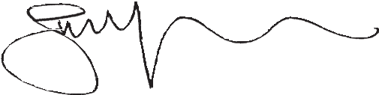
Sharon McGowan
Chief Executive Officer

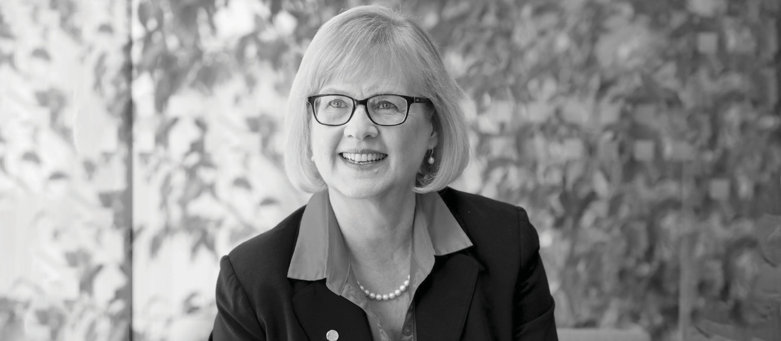
President's message
Through this last year, we learned that we could respond to challenges, by being agile, adapting, and staying grounded in our purpose.
“Through this last year, we learned that we could respond to challenges, by being agile, adapting, and staying grounded in our purpose.”
Emeritus Professor Linda Kristjanson AO
Stroke Foundation President

When I took up the role of President of Stroke Foundation during another COVID-impacted year, I was heartened to find an organisation focused on its mission, led by a dedicated team, buoyed by a strong community of volunteers.
I thank Professor James Angus AO for his visionary leadership and tireless work to ensure that our ambitious goals were realised during his tenure.
I speak for the Board, when I say how inspired we are by the generous contributions of survivors of stroke, whose insights and assistance allow us to improve the lives of others. On behalf of the Board, I offer you our sincere thanks.
Through this last year, we learned that we could respond to unforeseen challenges, by being agile, adapting, and staying grounded in our purpose.
It is this innovation and flexibility that defines Stroke Foundation’s new strategic plan: Stroke Strategy 2024 – Empowering, Supporting, Connecting.
To prevent stroke, improve access to treatment, and enable people to recover well, we must collectively empower, support, and connect our community of survivors, researchers, clinicians, and families.
We look forward to confidently implementing our new strategic plan in the years ahead and welcome your support as we take this journey together.

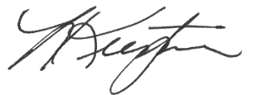

Emeritus Professor Linda Kristjanson AO
Stroke Foundation President

Goal 1 Fewer preventable strokes in Australia
We empowered a greater proportion of adult Australians to recognise the risks of stroke which can be changed, and in doing so increase their chances of preventing stroke.

Health Promotion Advisory Committee
The Health Promotion Advisory Committee provided expert advice on several policy submissions to Government consultations, including the National Preventive Health Strategy, Medical Research Future Fund (MRFF) Cardiovascular Mission Roadmap and Implementation Plan, and the Primary Health Care 10 Year Plan, helping to shape Stroke Foundation’s position on key health policy areas of critical importance to the Australian stroke community.

Ryman Healthcare Mobile Health Screening Service
In partnership with Stroke Foundation, the Ryman Healthcare Mobile Health Screening Service travels around Victoria delivering free blood pressure checks to Victorians.
Raising awareness of stroke risk factors, in particular high blood pressure, the service encourages participants to reduce their stroke risk by managing their risk factors and making healthy lifestyle choices. The health service includes a blood pressure check and a stroke risk assessment.
The Ryman Healthcare Mobile Health Screening Service was re-launched at Epworth Hospital Geelong in May, coinciding with World Hypertension Day. Services have been suspended since the re-launch due to COVID-19.

My health for life
By the end of 2021 more than 256,600 Queenslanders had a risk assessment with more than 13,600 completing the program.
The successful outcomes demonstrated include more than 70 percent met physical activity guidelines and 66 percent achieved waist circumference reduction. Over 48 percent reduced their total mentally unhealthy days.

Prevention Resources
For most Australians, stroke can be prevented by managing some key risk factors and living a healthy lifestyle. In 2021, a prevention framework was developed to help inform people about the risk of stroke and how best to reduce their risk. Prevention resources developed included a high blood pressure and stroke fact sheet and how to measure your blood pressure at home infographic.
Australia’s Biggest Blood Pressure Check (ABBPC)
ABBPC delivers free health checks in community settings – raising awareness of the link between high blood pressure and stroke; empowering Australians to know their stroke risk and understand how to manage it by getting a health check in a pharmacy or general practice. ABBPC campaign in partnership with Blooms The Chemist generated media across television, radio, print and online in 2021, with stories available to 1.33 million people.

StrokeSafe Speaker Program
The StrokeSafe Speaker Program grew by 50 percent in 2021, delivering 301 presentations to community groups, events, and workplaces, reaching almost 10,000 Australians with lifesaving F.A.S.T. (Face, Arms, Speech, Time) signs of stroke awareness and stroke prevention messages.
With ongoing COVID-19 restrictions in some states Stroke Foundation launched its first Facebook Live StrokeSafe presentation, which had more than 1,000 views. Importantly, 93 percent of post-presentation survey respondents reported an increased knowledge of the F.A.S.T. signs of stroke.
The program trained, through a mix of online and face to face, eight culturally and linguistically diverse (CALD) speakers; Mandarin, Cantonese, Korean and four regional speakers from Braddon TAS, Page NSW and Forrest WA. 42 (14 percent) presentations were conducted within populations with high stroke incidence; 27 in regional federal electorates and 15 in a priority language other than English.

Thanks to the generous support of Erica Foundation, Annie Danks Trust and The William Angliss Charitable Fund, Stroke Foundation was able to facilitate the rollout of much needed volunteer equipment in Victoria as part of the StrokeSafe Speaker Program

Prevention highlights

- ABBPC generated media across television, radio, print and online in 2021 with sores available to 1.33m people
- More than 256,600 Queenslanders had a risk assessment

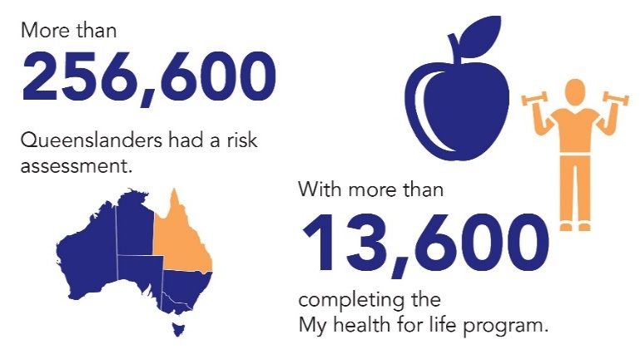
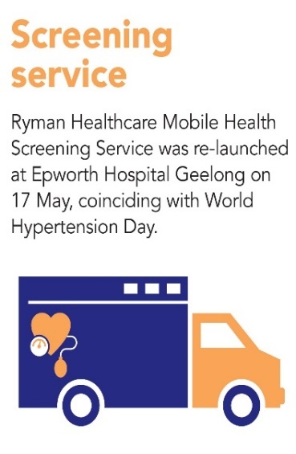

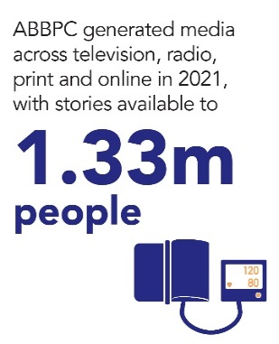

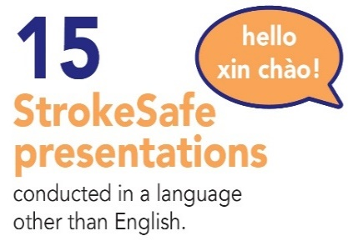

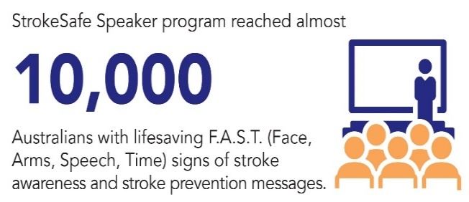
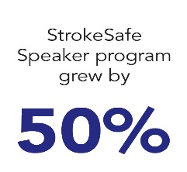

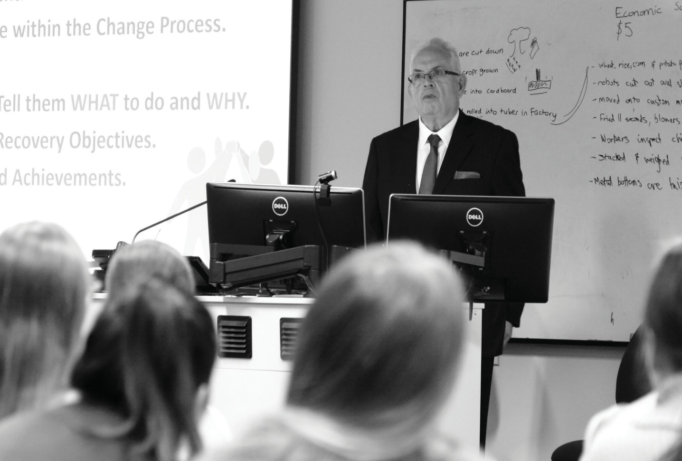
Case Study: Brian Beh

Brian Beh – 2021 Stroke Foundation Stroke Awards Improving Life After Stroke winner

“I hope my story can help people think about their own stroke risk and make some lifestyle changes for the better. Prevention is so important.”
Brian Beh
Survivor of stroke

Brian’s life changed in an instant when he had a stroke in 2016 at the age of 68. The retired management consultant and corporate executive had to learn to walk again and regain the use of his arm. The experience altered his outlook on life.

Brian’s health became a priority. The long-term smoker didn’t pick up a cigarette again and changed his diet, ditching foods high in sugar and salt – losing 17 kilos in the process. Brian now has renewed energy and commits much of his time to improving life after stroke by sharing regular blogs with the stroke community, presenting stroke awareness talks, and assisting clinicians with his insights on stroke treatment and rehabilitation.

Reflections from the past President
(2015 –2021)
Professor James Angus AO
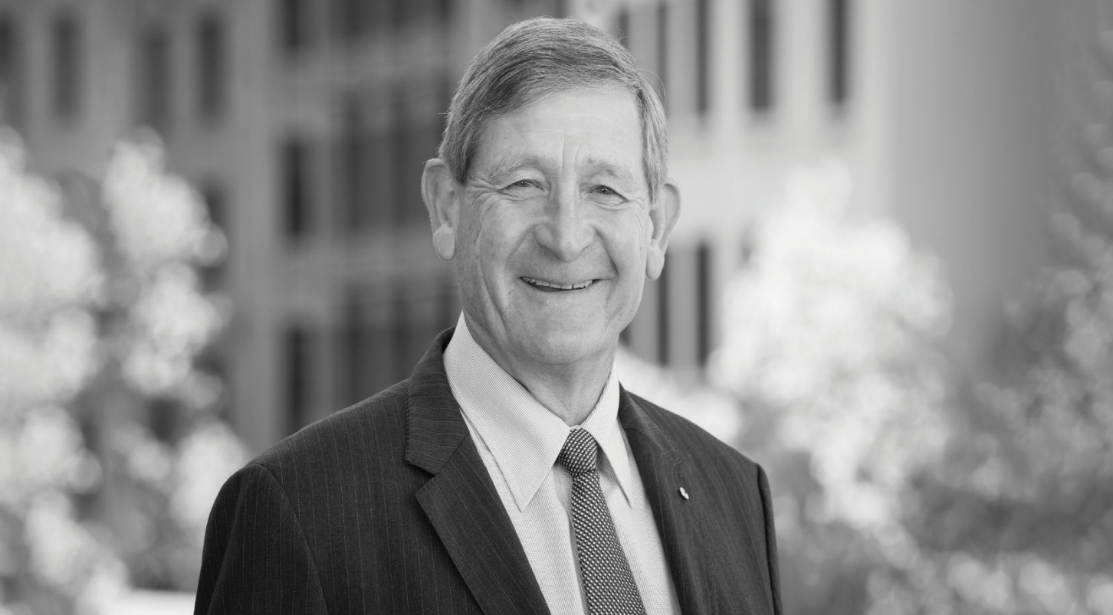

“It has been an enormous privilege and honour to serve Stroke Foundation as President and Chair of the Board of Directors over six years.”

The projects we are engaged in or have successfully completed owe much to the leadership and energy from our Chief Executive Officer Sharon McGowan and her Executive team.

Looking back, some of the highlights for me were a visit to Parliament with survivors of stroke and their carers as they told their stories and encouraged our leaders to listen and appreciate the message of prevention, saving lives and enhancing recovery.

We were delighted with the Federal support for the F.A.S.T. campaign. But data is critical in our work as we continued to gather evidence of gaps through our National Stroke Audit of Acute Services and Rehabilitation Services.

Our innovative online platform EnableMe, (launched in 2015), the Young Stroke Project, and more recently the development of the first Australian Childhood Stroke Rehabilitation guidelines in 2019 are making a real difference for survivors of stroke and healthcare providers. With the partnership from Little Stroke Warriors, we have developed a wonderful childhood resource; Our Family’s Stroke Journey.

In 2016 we launched a new Stroke Foundation logo and contributed to the game changing project of the first dedicated Mobile Stroke Unit (MSU) in Australia.

We launched our five-year Strategic Plan in 2017 and, in partnership with the Heart Foundation, developed a National Strategic Action Plan for Heart Disease and Stroke in 2018. In 2019 we were delighted with the Federal Government’s response with a 10 year $220m support for the Cardiovascular Health Mission.

For me a real buzz was the follow on from the highly successful Mobile Stroke Unit (stroke ambulance) research showing the importance of The Golden Hour in diagnosis of a cerebral clot or a bleed in metropolitan Melbourne.

This data backed the Frontier Medical Sciences Program application that saw the Federal Medical Research Future Fund contribute $40m towards new technologies to diagnose a clot in the golden hour potentially anywhere in Australia

I just wanted to highlight one activity that demonstrates the commitment of a very loyal collection of golfers that play twice a year in the Counterstroke Golf Classic. Their tireless support for our projects and advocacy of our message for over 20 years is legendary.

This short summary does not do justice to the full scope of Stroke Foundation’s work, but I am enormously proud of what progress has been made in our committed areas of prevention, saving lives and enhancing recovery from the devastating effects of stroke. I would like to thank the Directors, the employees, all our generous supporters, and the stroke community for your dedication and tireless commitment to the Foundation and its work.

I know I leave the Board in great hands, and I look forward to learning of further progress in years to come.
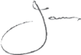

Professor James Angus AO
Former Stroke Foundation President

Goal 2 Ensure all Australians have access to evidence-based stroke treatment

We supported hospitals and healthcare providers across Australia to strengthen their capabilities in stroke care and rehabilitation services.

Mobile Stroke Unit (Stroke Ambulance)
2021 marked a celebration of the Mobile Stroke Unit (MSU) or Stroke Ambulance’s fourth birthday. Victoria’s MSU was dispatched 1,762 times (averaging seven callouts per day) and attended 558 patients across Melbourne, rendezvousing with incoming regional paramedics. The service was maintained despite the COVID-19 pandemic and has serviced 2,245 patients over its four years of operation.

Australian Stroke Alliance
Stroke Foundation partners with Australian Stroke Alliance in this $40 million research program, aiming to revolutionise stroke care by taking the emergency department to the patient. Stroke Foundation will lead consumer engagement and contribute to clinical education in preparation for the introduction of lightweight brain scanners in road and air stroke ambulances.

Emergency stroke telehealth services and treatment pathways
The $21.7 million NSW Telestroke Service connects patients with clinicians by video, speeding up stroke diagnosis and treatment. The service will run in more than 20 sites and is a joint initiative between the State and Federal Government.

The first stage of a $9.7 million commitment from WA Government to expand the Statewide Telestroke Service was implemented in September 2021 and received more than 100 referrals in its first eight weeks.

F.A.S.T. across the country
Stroke Foundation’s 2021 population health survey found just 30 percent of Australians recognised (unprompted) two or more signs of stroke; and only 14 percent of Australians who speak languages other than English at home can name two or more signs of stroke.

With the support of the New South Wales, Western Australian, Tasmanian and Federal Government, F.A.S.T. (Face, Arms, Speech, Time) community education continued to expand into regional and culturally and linguistically diverse communities across the country to increase awareness of the signs of stroke.

F.A.S.T. NSW
Stroke Foundation is proud to partner with NSW Health to deliver F.A.S.T. Community Education in support of the NSW Telestroke Service. F.A.S.T. community education maximises the benefits of the NSW Telestroke Service by reiterating the urgency of calling an ambulance at the first sign of stroke. The outcome of F.A.S.T. education in regional NSW saw an increase in awareness of at least two of the signs of stroke from 22 percent (2020) to 42 percent (2021).

F.A.S.T. WA
The WA F.A.S.T. grant of $200,000 over four years ends on 30 June 2022. This funding enabled Stroke Foundation to deliver the F.A.S.T. message to more than 2,900 face-to face participants in 2021 (an increase of more than 20 percent from commencement of the grant in 2018-19), and to more than 4,000 social media users due to advertising in late 2021 targeting at-risk populations such as regional Western Australians.

Discussions are underway with the WA Department of Health, to secure $800,000 over four years to continue and grow this important community education program.

F.A.S.T. TAS
More than 450 Tasmanians heard lifesaving messages about stroke prevention and F.A.S.T. at 25 presentations and via three information stands state-wide. The annual population health survey found Tasmanians have Australia’s highest recognition of the F.A.S.T. signs of stroke with 39 percent recognising two or more signs compared to 30 percent nationally, demonstrating the impact of this important program.

National Stroke Week 2021
The 19th annual National Stroke Week, held in August, encouraged people to be ‘United by Stroke’. The campaign focused on recognising the F.A.S.T. signs of stroke – and the lifesaving importance of calling an ambulance at the first sign of stroke. More than 2,400 organisations and individuals registered across Australia and hosted online events and webinars to share the National Stroke Week message.
Clinical Guidelines
The Stroke Living Guidelines pilot project was successfully completed in 2021, an international first. Evaluation of the project demonstrated that clinicians had higher levels of trust in the living guidelines resulting in increased access and use of the information in their daily practice compared with the traditional paper based guidelines model.

Treatment highlights

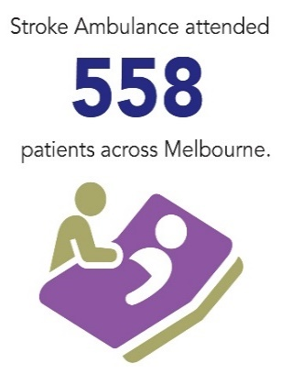
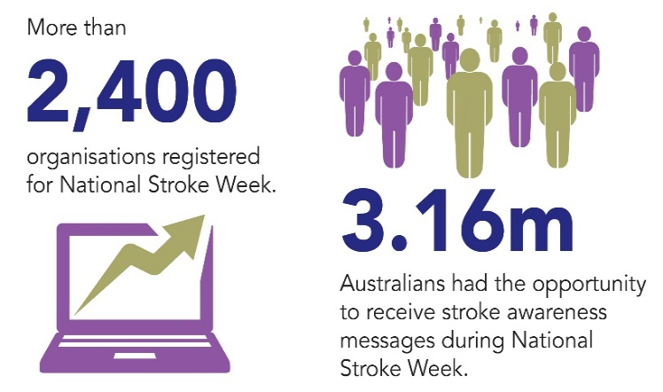

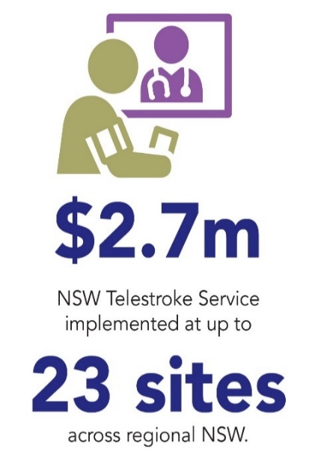
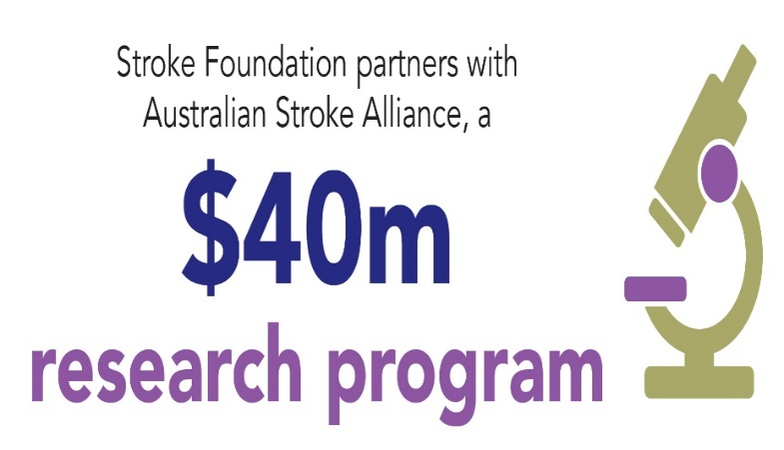

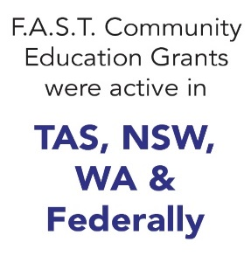

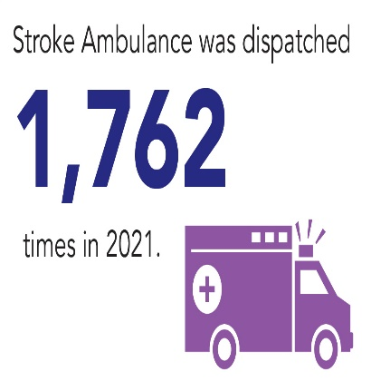
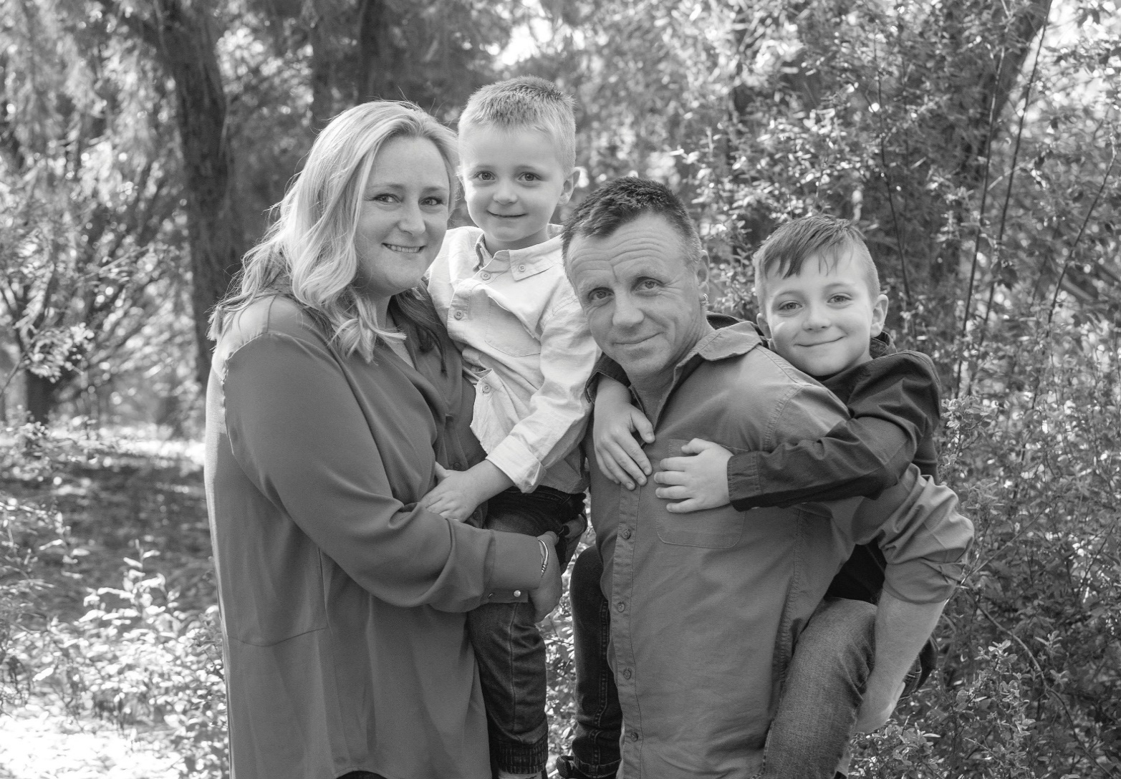
Case Study: Kelly Wilson
“My outcome was incredible thanks to the stroke ambulance and its crew. I hope more Australians are able to benefit from this lifesaving technology in the future.”
Kelly Wilson
Survivor of stroke

Kelly is incredibly grateful for stroke research and innovation. Without it, her life would look very different.

The mother of two young children suffered a stroke a week after her 40th birthday. Fortunately her husband Bruce was running late for work that day, recognised she was having a stroke by her facial droop and called triple zero (000) straight away. Australia’s only Mobile Stroke Unit was dispatched and Kelly received a brain scan and thrombolysis treatment, to break up the blood clot in her brain. Thanks to the technology in the ambulance, it all happened in her street, saving precious time and brain cells. By the time the ambulance was on its way to hospital, Kelly was able to move her arm again and her speech was returning.

F.A.S.T. Federal Grant Project

In its second year the federally funded F.A.S.T. project ($800,000 over four years) reached more than one million Australians with the signs of stroke awareness messages.

A multi-channel advertising campaign targeted regional and culturally and linguistically diverse (CALD) communities in the 40+ age bracket, resulting in more than four times the number of views to the signs of stroke website pages compared with 2020. New creative assets were developed and translated into eight languages across press, radio, social media and digital display banners between March and November.

F.A.S.T. resources (bookmark, wallet card, magnet), StrokeSafe speaker presentation slides and speaking notes were also translated into eight CALD languages for the project.
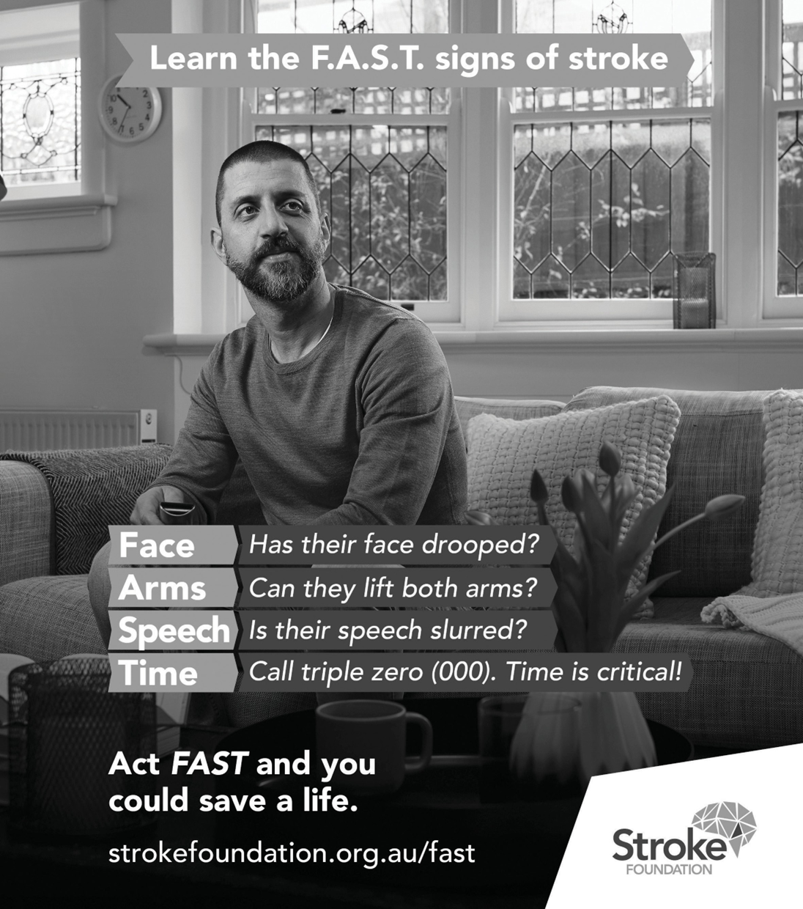
“As a survivor of stroke who knew nothing about stroke before it happened to me, I am so glad
to be able to spread awareness about what stroke is so others can get help sooner than I did.”
Bill Gasiamis
Survivor of stroke

Goal 3 Enhance recovery to help Australians live well after stroke

We reached out to those impacted by stroke to ensure more Australians connected with and accessed trustworthy information, resources, and post-stroke support.

National Stroke Audit
A total of 115 hospital services participated in the National Stroke Audit of acute services. 3,890 case notes were reviewed to assess the quality of hospital-based stroke care in Australia. Improvements for most aspects of care were reported but further work is needed to improve access and timely administration of clot busting medication. An external review of the audit was undertaken with plans to refine and improve the audit program to ensure greater impact for improved patient care.

StrokeLine
StrokeLine’s health professionals provide advice on stroke prevention, treatment, and recovery. StrokeLine is a practical, free, and confidential service. StrokeLine provided information and support to 2,648 survivors of stroke, their families, carers, and friends. StrokeLine is a highly regarded service, with 89 percent of clients saying they would recommend it to someone else.

My Stroke Journey
The definitive guide for survivors of stroke, their families, and carers for navigating the journey from hospital to home after stroke, and beyond. My Stroke Journey is now a suite of resources, with versions for Aboriginal and Torres Strait Islander peoples, and for parents and carers whose child has had a stroke. With generous support from donors and partners, this resource is provided freely to all hospitals. 147 hospitals delivered My Stroke Journey to 23,332 Australians.

EnableMe
Our stroke recovery website, EnableMe.org.au, connects survivors, families and carers to information and support, no matter where they are in Australia. 124,171 survivors of stroke, their families, carers and supporting health professionals accessed 402,537 pages of information on EnableMe.

Young Stroke Project
The Young Stroke Project is a three-year codesigned project delivering better information for people aged 18 to 65. A Lived Experience Working Group made up of survivors and carers has been key to the project’s success, providing advice, facilitating workshops and delivering new content. 36,169 people visited the Young Stroke Project website in 2021, accessing videos, podcasts and blogs. 93 percent of people surveyed found the new resources helpful.

The Young Stroke Project is funded by the Australian Government Department of Social Services.

Childhood Stroke
In November 2021, Little Stroke Warriors became part of Stroke Foundation, formalising our partnership and securing the future of advocacy and support for childhood stroke.

Stroke Foundation employees and volunteers work together to manage Little Stroke Warriors’ communications. The StrokeLine team take an active role in supporting both the public community Facebook group (826 followers) and the private group of families impacted by childhood stroke (which has 466 members).

The Paediatric Acute Code Stroke (PACS) project continues to progress towards its goal of transforming the care of children with stroke with recruitment of John Hunter Hospital in NSW and Starship Children’s Hospital, Auckland NZ.

Stroke Outreach Program (StOP)
In Tasmania, there were more than 230 survivors of stroke referred to our Stroke Outreach Program (StOP) on discharge home from 11 clinical areas in acute and rehabilitation hospitals. More than 500 risk factors were identified via phone consultation with hypertension and high cholesterol the most common.

The NSW Regional Outreach COVID-19 response program was funded by Newcastle Permanent Charitable Foundation and resulted in 179 referrals across 13 hospitals. Of 179 referrals, 152 information packs were provided and there were 27 referrals for outbound telephone support.

Media Mentions & Website sessions
Stroke Foundation harnesses the power of Australia’s news media to share our message, and featured in 1,371 news articles, radio broadcasts, and television news bulletins with an opportunity to reach three million Australians.

Stroke Foundation’s website performed strongly in 2021 recording 1,010,814 (26 percent increase) sessions with 793,385 (29 percent increase) new users. The most popular page was signs of stroke with 135,363 page views.

Recovery highlights
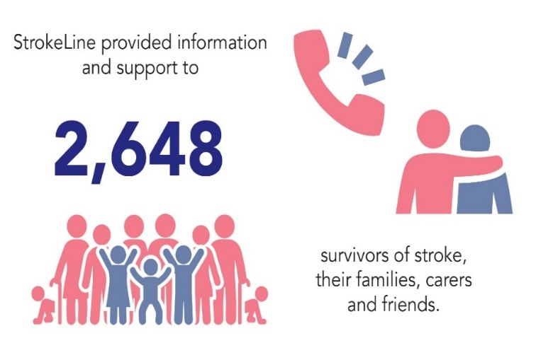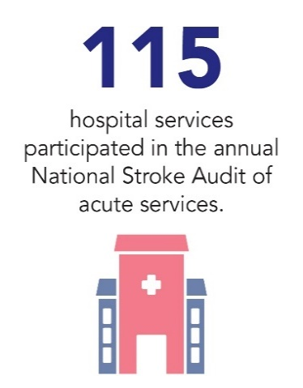

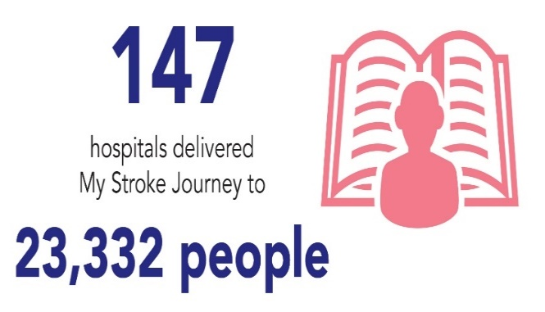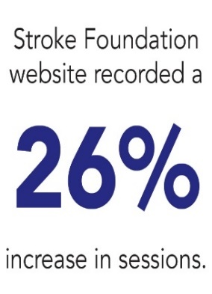
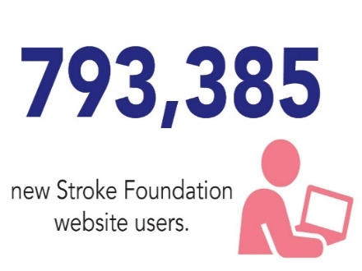
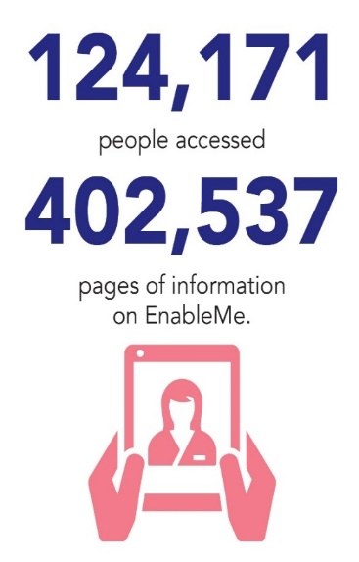

Case Study: Justin Kickett
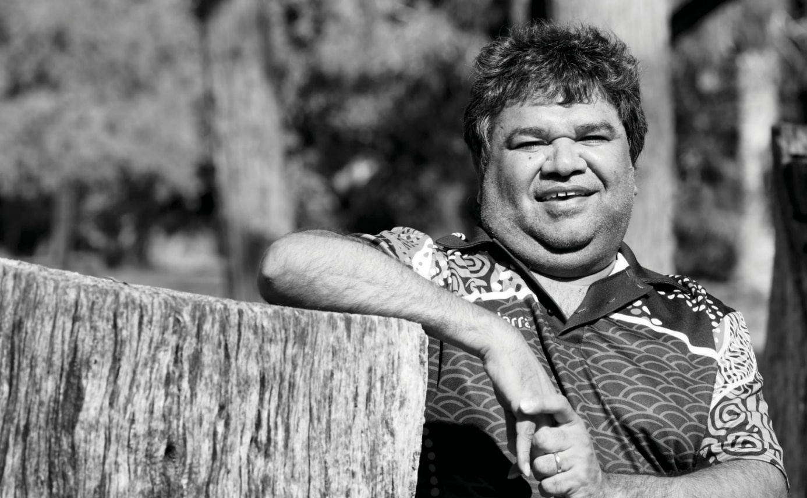
“I tried to rush my recovery at first to get back to how life used to be, but soon learnt it takes time, effort and patience. Our Stroke Journey will help guide and support many people, like me, in the future.”
Justin Kickett
Survivor of stroke

Stroke has impacted three generations of Justin’s family, including himself, highlighting the prevalence of stroke in First Nations communities.
The proud Whadjuk Noongar man and father of four was 32 years old when stroke struck. He found his recovery incredibly challenging. Justin spent one month in hospital learning to walk again. He was desperate to get home during this time, but then found the transition home more difficult than expected.
Justin’s rehabilitation included speech therapy, occupational therapy and physiotherapy, a healthier diet, exercising and he also quit smoking and drinking.
While Justin lost the use of his right arm, he is now able to drive a modified car – a key step in regaining independence.
Justin shared his story in 2021 to help launch Our Stroke Journey, an information booklet about life after stroke specifically designed to help Aboriginal and Torres Strait Islander peoples.

Our Stroke Journey
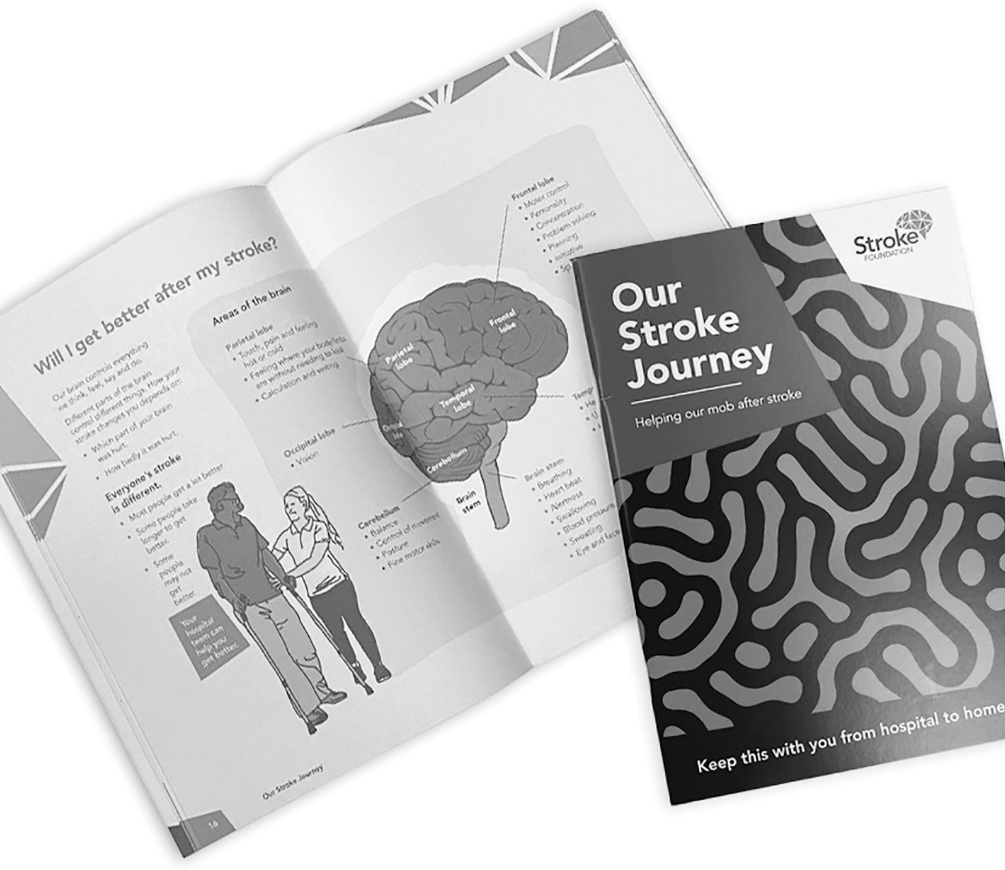

Our Stroke Journey was launched in August 2021 and responds to the unique information needs of Aboriginal and Torres Strait Islander peoples.
Our Stroke Journey was made possible because of our partnership with Queensland Aboriginal and Islander Health Council (QAIHC). QAIHC led consultations across Queensland with Aboriginal survivors of stroke, their families and with health workers. Their work enabled the development of a clear vision for the project. The Federal Parliament Press Gallery Midwinter Ball generously supported it's early development, along with The Elizabeth and Barry Davies Charitable Foundation.
Aboriginal and Torres Strait Islander survivors of stroke, families and health workers provided extensive advice on content most needed by their communities, and on culturally appropriate information delivery. Our Stroke Journey includes stories from Aboriginal and Torres Strait Islander survivors of stroke, families, and health workers.
Our Stroke Journey represents a big step forward in ensuring Aboriginal and Torres Strait Islander peoples get the information and support they need after stroke.

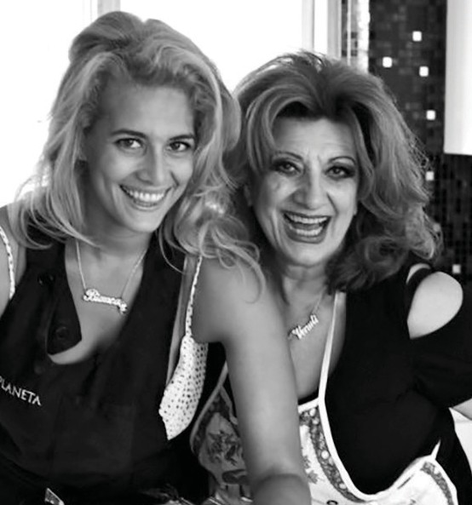
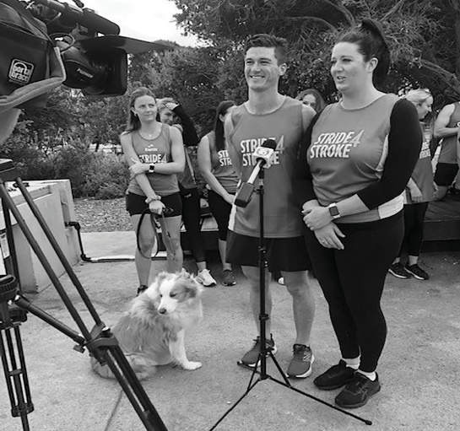
- Bec (survivor of stroke) and Dan Maitland being interviewed for Stride4Stroke
2
1
- Maria and Bianca Venuti. Story in The Senior: Maria sings at 80th birthday to raise funds for Stroke Foundation.
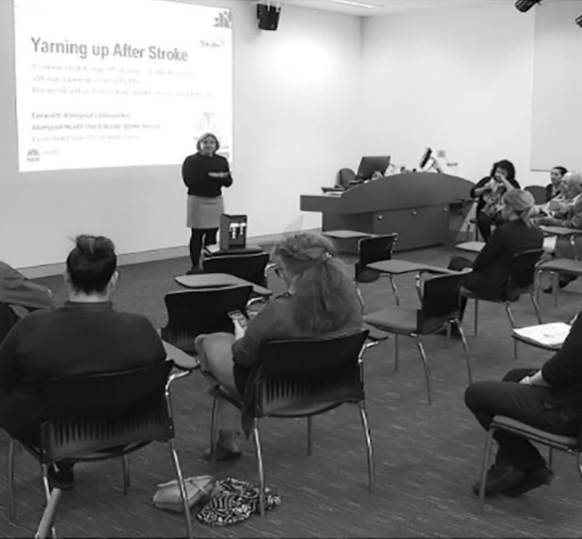
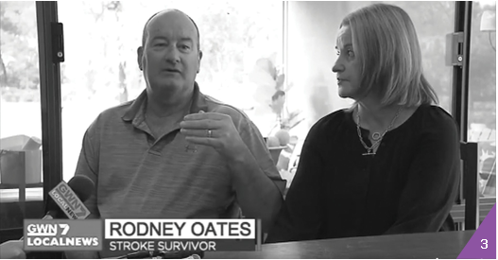
4
- Survivor of stroke Rodney Oats, being interviewed during National Stroke Week on GWN7 News.
- Story on NBN News NSW: Unique initiative to help Indigenous Australians recover from stroke.

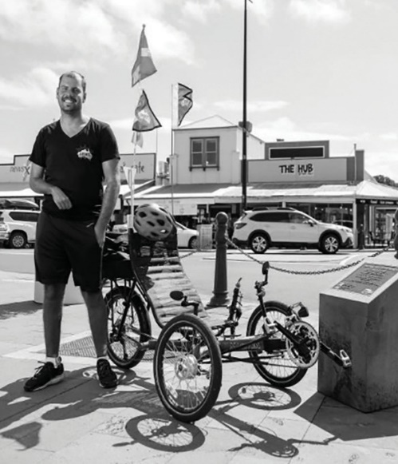
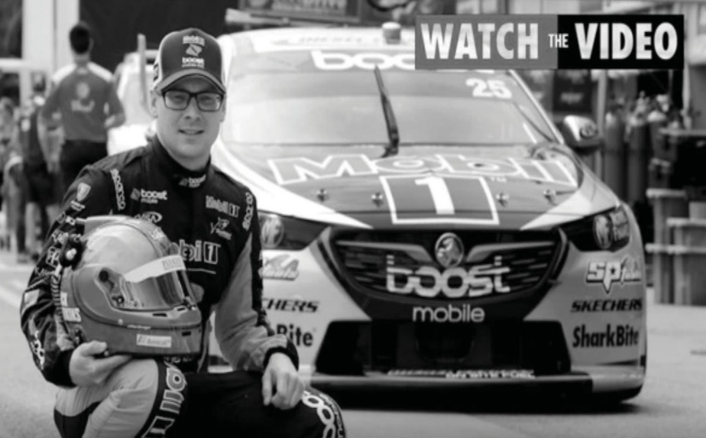
- Story on news.com.au: Supercar driver Jack Perkins talks about having a stroke. Image: news.com.au
6
5
- Story featured in The Standard, Warrnambool: Tommy Quick (survivor of stroke) is riding with a cause. Image: Morgan Hancock

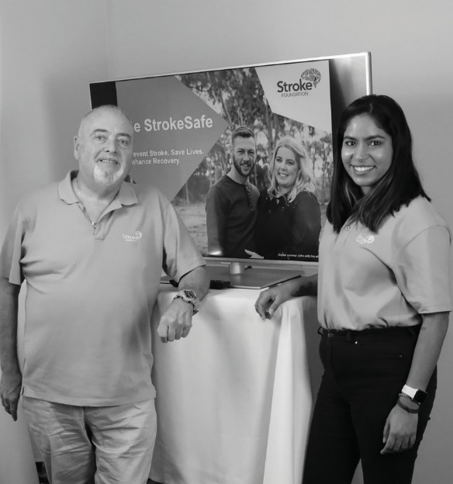
8
7

- Photo shoot with David Genat and Lee Carseldine for the Towel Challenge, a social media initiative that raised funds and awareness of stroke.
- Priya Sharma and Bernard Hannelly (survivors of stroke and StrokeSafe Speakers) recording the online speaker training for new recruits.

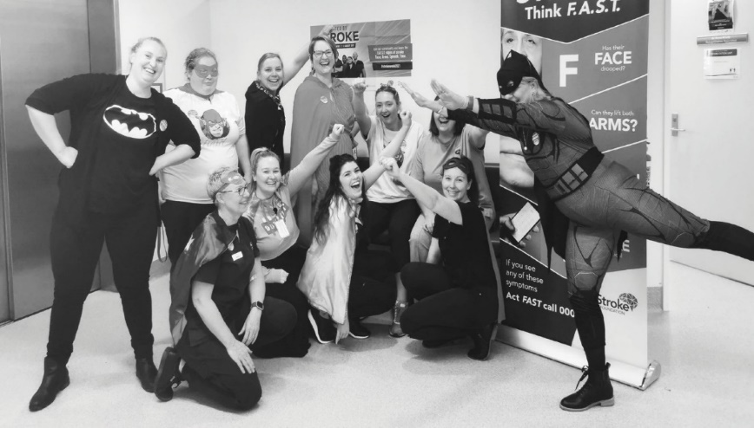
9

- Mercy Hospital Team participating in National Stroke Week activities
- Mandi & Co – On The Run team raised over $10,000 for Stride4Stroke

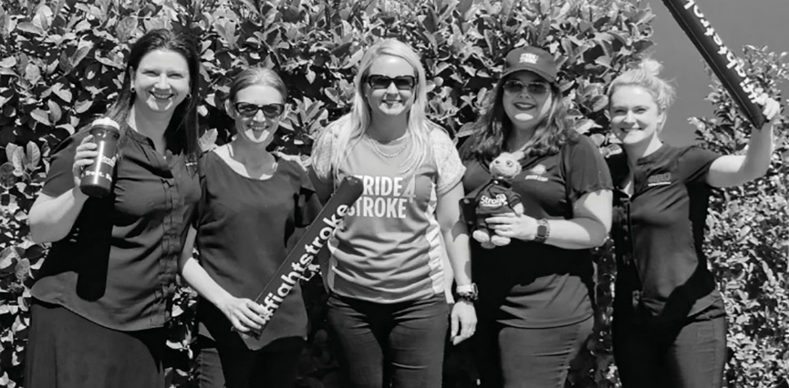
10

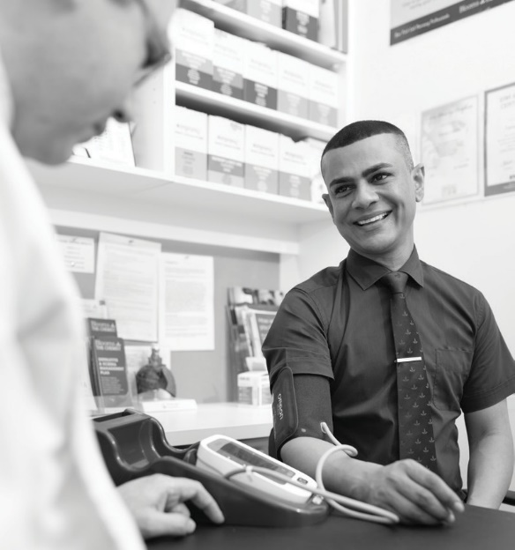
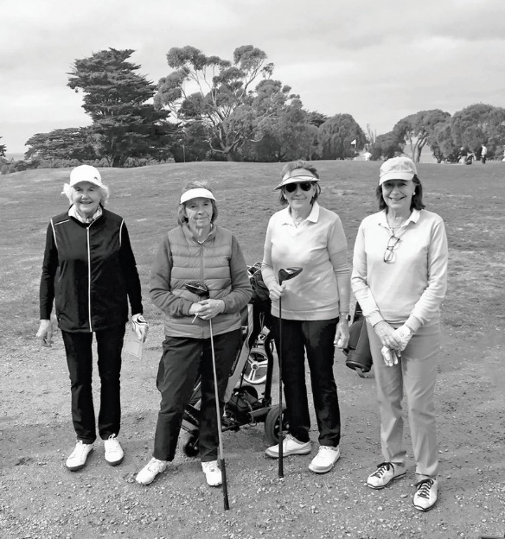
12
11

- Tamie Fraser (left) and players at Flinders Golf Club for the Counterstroke Golf Classic.
- Australia's Biggest Blood Pressure Check partnered with Blooms The Chemist.

Goal 4 Champion research instroke
Stroke Foundation is committed to fostering the next generation of leaders in stroke research through its investment in our annual research grant program.
Research Grant Program
Four research projects shared in almost $300,000 of funding through Stroke Foundation’s grant round this year. These projects all focus on improving quality of life for survivors of stroke and have an element of telehealth technology.
This will keep our research moving forward, making stroke care more equitable and accessible for all Australians, regardless of where they live.
Lady Marigold Southey Aphasia Research Grant (up to $100,000)
This is Stroke Foundation’s first dedicated aphasia research grant in its 25-year history. It has been made possible through the generosity of Stroke Foundation Patron Lady Marigold Southey AC. This inaugural grant aims to investigate recovery pathways to address this debilitating condition which affects more than 120,000 Australians today. The successful recipient of the grant was Dr Jessica Campbell.
- Dr Jessica Campbell, University of Queensland CHAT-Maintain: Maintaining language and quality of life gains with low-dose technology-delivered aphasia therapy.
Seed Grants recipients (up to $70,000)
Three early and early-mid career research seed grants up to $70,000 were awarded to address evidence and implementation gaps in stroke prevention, treatment and recovery.
- Dr Natalie Fini, The University of Melbourne, Personalised physical activity programs for stroke survivors.
- Dr Emma Wallace, University of Sydney, A dysphagia telerehabilitation program for stroke survivors living in the community – evaluating the effectiveness and feasibility.
- Dr Brooke Ryan, University of Technology Sydney, Surviving and Thriving After Stroke (STARS): Family-focused interventions for stroke survivors with children.
Endowment grant project updates
Nancy and Vic Allen Stroke Prevention Memorial Fund – 2021–2022 grant awarded to Professor Coralie English, University of Newcastle
i-REBOUND after stroke – development of a website to support people with stroke to eat well and move more. Codesigned with survivors of stroke, it will include exercise videos, menus and cooking demonstrations, featuring survivors of stroke. The website will be trialled in 2022 and housed on Stroke Foundation's EnableMe survivor of stroke resource and online community.
The project is progressing extremely well, with quality content generated. The prototype for the website has been finalised and is being handed over to the development team to be built. Survivors of stroke have guided the project team every step of the process.

Case Study: Dr Heidi Janssen
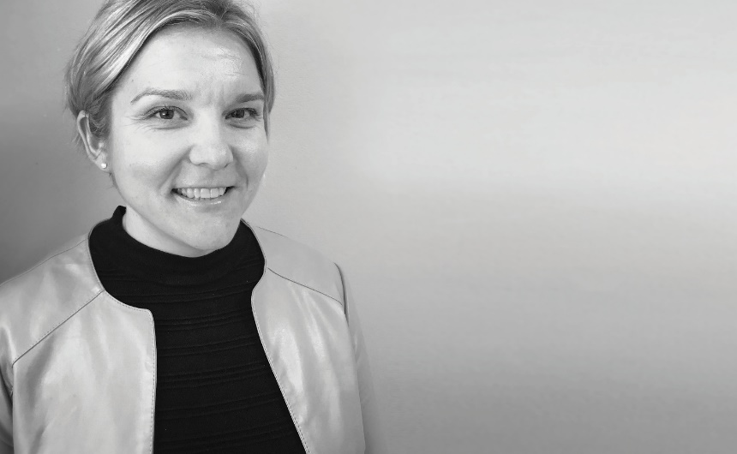
Dr Janssen was awarded a $50,000 Seed Grant in 2021 as part of the Stroke Foundation’s Research Grants Program. This enabled her to begin the project “Yarning up After Stroke.”
Tim Glendinning Memorial Fund for Young Adult Stroke – 2021–2022 grant awarded to Dr Alyna Turner, Deakin University
Resuming Employment after Stroke: Enhancement through Telecoordination – RESET Rural Expansion
Returning to work after stroke is an important rehabilitation milestone. This study, of a telehealth delivered return to work support service, aims to increase the rates of successful return to work for people in rural areas where support is limited.
A working group of service providers and people with lived experience of stroke, has provided feedback on the RESET approach (continuous support by a single coordinator and telehealth to access rural locations). It is supportive but emphasises the need to continue support beyond six months post stroke.
Gavin Paul Bennier Memorial Research Fund – 2019–2022 grant awarded to Professor Vincent Thijs, The Florey Institute of Neuroscience and Mental Health
Professor Thijs is investigating the prevalence of the rare brain disorder Cerebral Amyloid Angiopathy (CAA) in young survivors of stroke. CAA causes bleeds on the brain and is more commonly associated with dementia and older people resulting in missed or late diagnosis of this condition in younger people.
Dr Janssen, from the Hunter New England Local Health District, is striving for all Australians to be given equal opportunity to recover well from stroke in a culturally appropriate and safe way.
She is working with Aboriginal and Torres Strait Islander peoples to develop a yarning-based tool to empower people to self-manage their recovery. The yarning tool will be based on a similar tool (i.e. the Take Charge tool) which was developed in New Zealand, and which has been shown to improve quality of life and reduce disability after stroke in Indigenous peoples of New Zealand.
Heidi’s work is vital because stroke is almost twice as common, and the stroke related burden is almost three times greater in Aboriginal and Torres Strait Islander peoples.

Goal 5 Grow our impact and manage our charity effectively and efficiently
As a national organisation we developed programs and services which served the needs of all Australians, regardless of their location.

Governance
Since its incorporation in 1996, Stroke Foundation has been governed by an independent Board
of Directors. The Board is supported by the expertise of leading health professionals and researchers in stroke and is informed by survivors of stroke, carers, and their families.
Stroke Foundation’s corporate performance is overseen by the Audit, Finance, Investment and Risk Committee and the Governance and Nominations Committee.
Advocacy
Stroke Foundation is an apolitical organisation, meaning we will engage and partner with all Australian governments to influence public health policy and secure support for programs which advance our mission. We encourage our wider community of survivors of stroke and their own networks to share their personal stories with their own local elected Members, to highlight the policy and system changes needed to reduce the burden of stroke on our community.
People and Culture
Stroke Foundation delivered several key initiatives for employees and volunteers in 2021. This included workshops on culturally and linguistically diverse communities and mentoring for the Leadership team, a restructure of the People and Culture team embracing a Business Partner model, a focus on Wellness, Mental Health First Aid training, updating of policies, retraining on policies regarding Whistleblowing, Complaints Handling and Harassment and Bullying were conducted for all employees.
Volunteers
Stroke Foundation’s volunteer workforce continues to thrive despite another challenging year of COVID-19 restrictions. Volunteers contributed 7,500 hours in 2021 with more than 270 volunteers working across 36 roles in various programs, marketing, media and advocacy, our Board, committees and councils. Many of our volunteers hold close personal connections with our mission and vision, and we look forward to continuing to work together to advance our mission.
Stride4Stroke
Stride4Stroke is Stroke Foundation’s flagship community fundraising event, where we encourage the community to get active during the month of November. In 2021, Stride4Stroke saw its most successful year since its launch in 2015. An incredible 1,390 Striders hit the track, pool, rode a bike or set new activity goals as part of stroke rehabilitation, to reduce their risk of first time or recurrent stroke. Australians logged more than one million Moving Minutes and raised a record breaking $489,000.
Fundraise4Stroke
For the second year in a row, Fundraise4Stroke enabled Australians to fundraise their own way for Stroke Foundation; including weddings, school activities and workplace events. More than $200,000 was raised by 177 fundraisers, whilst tens of thousands of Australians learned about stroke risk factors through awareness raising and sharing on social media.

Case Study Jake Vincent

2021 Stroke Foundation Stroke Awards Volunteer of the Year winner
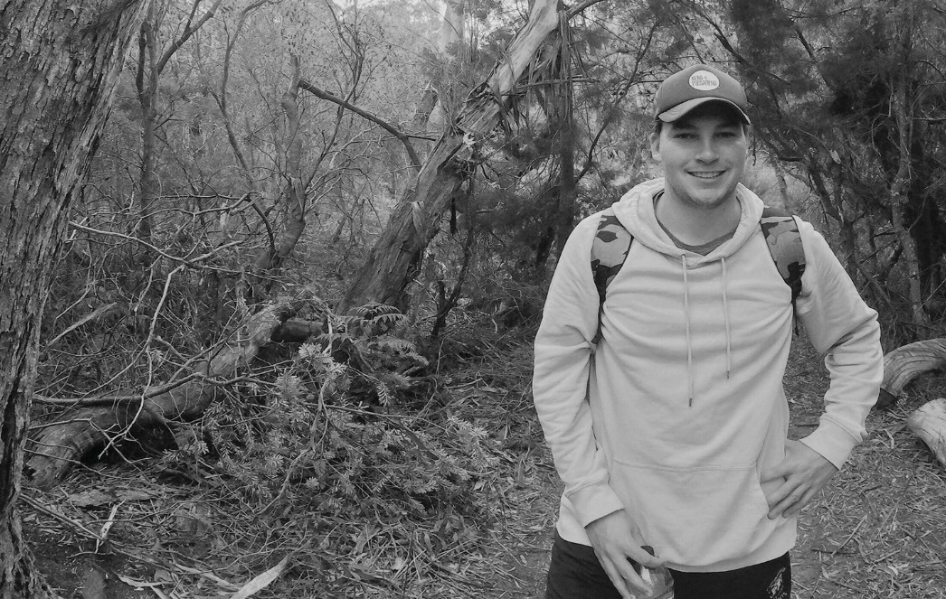
Jake experienced a stroke at the age of 22 and embraced volunteering for Stroke Foundation in the StrokeSafe Speaker program just six months later. Jake is particularly passionate about raising awareness that stroke can happen at any age He has established a reputation as an inspirational public speaker and is an enthusiastic participant in health forums and media opportunities where he can provide a consumer voice on stroke.
In 2021, Jake won the Stroke Awards Volunteer of the Year Award for his dedication and generosity. His goal is to help prevent strokes and spread the F.A.S.T. message so that more people understand the need to seek immediate medical help for stroke.
Tasmanian Iconic Walks
The fourth annual Tasmanian Iconic Walks (TIW) one day hiking event in the Tasmanian wilderness, run by the TIW committee, saw more than 70 participants trek from Tasman Arch to Fortescue Bay; raising more than $41,000 in November.
Towel Challenge
Australian Survivor All-Star contestants Lee Carseldine and David Genat continued the Towel Challenge campaign in 2021 to honour Lee’s mum Elizabeth.
“Hopefully out of something so tragic as losing my mum, something good can happen.”
The social media campaign reached almost half a million people worldwide thanks to celebrity posts from Australian Survivor All-Star Jacqui Patterson, athlete Courtney Hancock, rugby player Eloni Vunakece and actor Hugh Sheridan. In addition, paid advertising reached more than 355,000 people nationally.

Financials
The operating result for the 2021 year was a net surplus of $0.9m.
The surplus will be used to support the implementation of mission focused projects in 2022 as part of the Foundation’s new 2024 Strategic Plan – Empowering, Supporting and Connecting.
During the year, the Foundation continued to deal effectively with the ongoing impacts of the COVID-19 pandemic.
Despite ongoing restrictions, fundraising programs were able to maintain the growth in regular giving donors, now the largest income stream providing a stable foundation to support vital services such as StrokeLine and EnableMe.
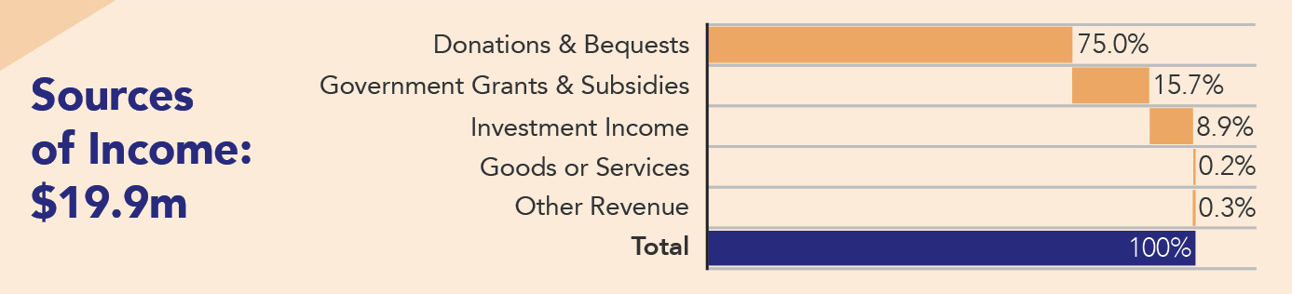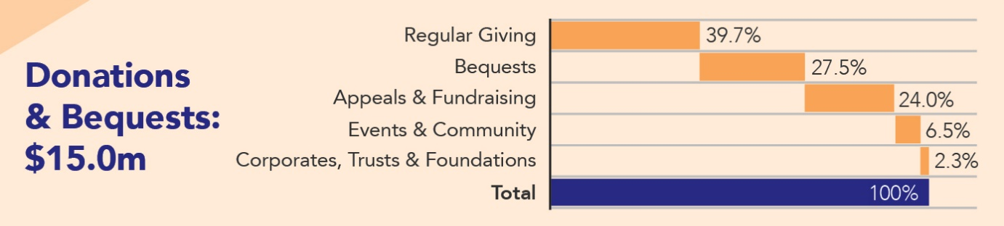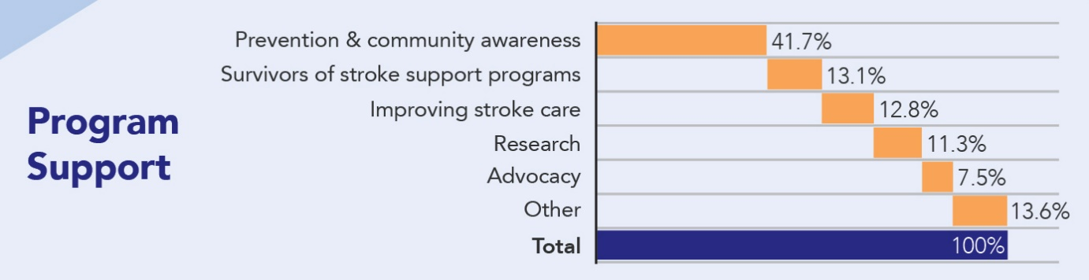

This provides a relatively reliable, consistent source of ongoing revenue. Supplementing this was improved investment earnings on the back of growth in the share market.
Government income and costs both reduced when compared to 2020 due to the completion of several programs supported by fixed term grants which were not renewed.
Maintaining the health and wellbeing of our employees, volunteers and the stroke community continued to be our top priority as we adjusted marketing and consumer engagement plans to respond to COVID-19 related restrictions on public movement. However, due to the impact of the pandemic, several funded research programs were delayed.
Highlights
- Community fundraising continued to grow despite the impact of COVID-19.

- The QLD Government supported program, My health for life (delivered in partnership with Diabetes QLD) secured a further $2.5m of funding over three years; enabling more Queenslanders to reduce their chronic disease risk (including stroke) through the adoption of a healthy lifestyle.

- Secured $0.5m over two years under a Federal action plan to support Australians with heart disease or stroke to make the best recovery possible and participate in the community.

- The Tasmanian Government's Community Healthcare Initiatives program provided a two year $0.4m grant for F.A.S.T. stroke education, quality improvement with clinicians and post-discharge follow up of survivors of stroke.

Highlights
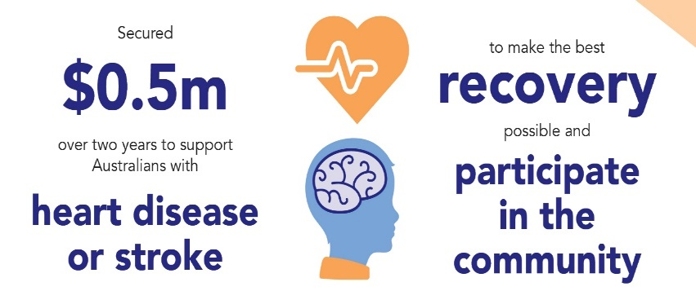
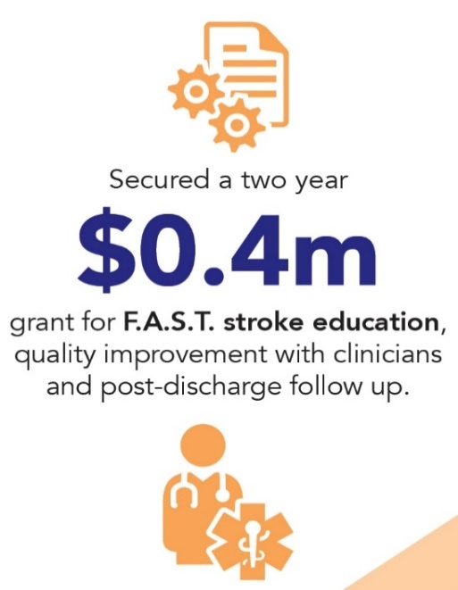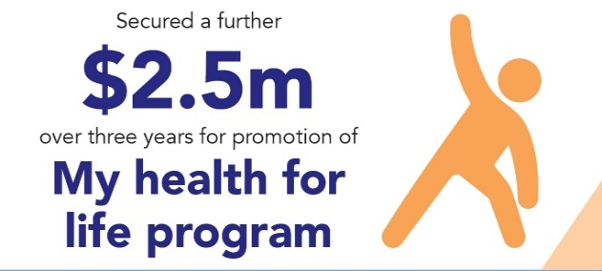

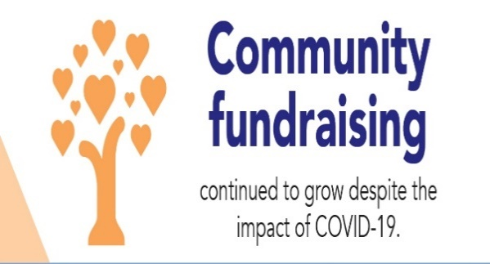

Team Stroke
As Australia’s only national stroke charity, we are privileged to have many talented, passionate, and generous supporters standing alongside us helping to advance our mission to prevent stroke, save lives and enhance recovery.
We are the trusted voice of stroke in Australia but without this incredible team and inspiring community, that role would be so much harder to fulfil.
We thank all those who inspire us and champion our work:
- Our Patrons.
- Our Ambassadors.
- Our Board.
- Our Clinical Council, Consumer Council, Research Advisory Committee, and Finance Investment & Risk Committee.
- Our Childhood Stroke Advisory Group, Health Promotion Advisory Committee and Endowment Committee.
- Governments, health services and health professionals, right across the country.
- Our employees, our amazing volunteers, and our supporters.
- Our corporate supporters and Trust & Foundations that partner with us.
- And to all those who are personally impacted by stroke – you are our inspiration.
We express our heartfelt thanks to you all.
Thank you for joining with us to prevent, treat and beat stroke

Stroke Awards 2021 Winners
We congratulate and honour those who continually go above and beyond to make a positive difference for stroke in Australia.
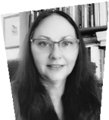
President’s Achievement Award
proudly sponsored by Ipsen:
Dr Eleanor Horton

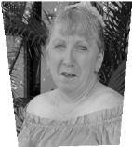
Creative Award proudly sponsored
by Marmalade:
Trish Higgins

Fundraiser of the Year Award
proudly sponsored by
Precision Fundraising:
Lee Carseldine & David Genat

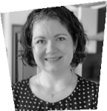
Courage Award
Emma Beesley

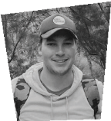
Volunteer of the Year Award
proudly sponsored by
NAB Education and
Community Business: Jake Vincent

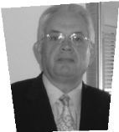
Improving Life after Stroke Award
proudly sponsored by Australian
Philanthropy Association:
Brian Beh

Stroke Foundation and
Stroke Society of Australasia
Stroke Care
Champion Award: Langduo Chen

Thank you to all our supporters

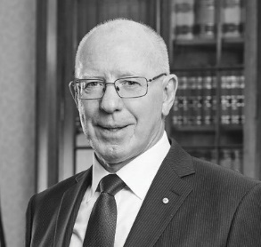
Patron-in-Chief
His Excellency General the Honourable David Hurley AC DSC (Retd)

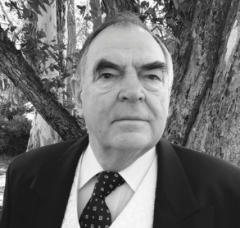

Patron
Mr David Brownbill AM

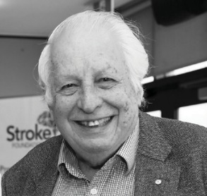

Patron
Sir Gustav Nossal AC CBE

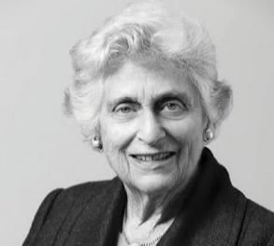
Patron
Lady Marigold Southey AC

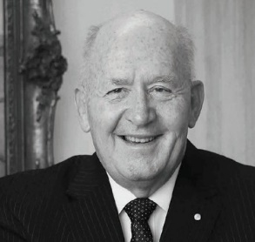
Ambassador
General the Honourable Sir Peter Cosgrove
AK CVO MC (Retd)

President
Emeritus Professor Linda Kristjanson AO (appointed 6 May 2021)
Professor James Angus AO (retired 5 May 2021)

Vice President
Mr Christopher Nunn (appointed 6 May 2021)
Mr Christopher Edwards
(resigned 9 June 2021)

Directors
Professor Amanda Thrift
Professor Bruce Campbell
Ms Jennifer Muller
PSM Ms Karen Vernon
Ms Sally Bateman
Mr Christopher Edwards (resigned 9 June 2021)
Mr Andrew Matthews
Mr Christopher Nunn
Ms Janice Thomas
Mr Peter Nikoletatos (appointed 2 December 2021)

Company Secretary
Mr Matthew Oakey

Clinical Council
Professor Bruce Campbell, Chair
Dr Rohan Grimley
Professor Susan Hillier
Dr Claire Muller
Associate Professor Erin Godecke (resigned 25
August 2021)
Ms Skye Coote
Dr Timothy Ang
Professor Natasha Lannin
Professor Steven Faux
Associate Professor Seana Gall
Associate Professor Mark Mackay
Associate Professor Martin Jude OAM

Health Promotion Advisory Committee
Associate Professor Seana Gall, Chair
Dr Siobhan Hickling
Professor Corneel Vandelanotte (resigned 1 December 2021)
Professor David Thomas
Professor Mark Harris
Professor Simone Pettigrew
Mr Nic Stephen
(resigned 25 March 2021)

Consumer Council
Ms Jennifer Muller PSM, Chair
Ms Julie Collins
Ms Nadia Moffatt OAM
Mr Kevin English
Mr Tony Finneran
Mr Tony Rolfe, Deputy Chair (appointed 5 May 2021)
Ms Saran Chamberlain
Mr Nic Stephen
Deputy Chair (resigned 25 March 2021)
Ms Kim Beesley
Ms Jasmina Behlic
Ms Elisha Deegan
(appointed 25 February 2021)

Audit, Finance, Investment and Risk Committee
Mr Christopher Edwards, Chair (resigned 9 June 2021)
Mr Peter Fekete
Mr Alan Lahiff
Mr Andrew Matthews
Mr Christopher Nunn (appointed Chair
15 June 2021)
Narayan Prasad
(appointed 2 December 2021)

Governance and Nominations Committee
Ms Karen Vernon, Chair
Professor James Angus AO (retired 5 May 2021)
Ms Sally Bateman
Mr Christopher Edwards (resigned 9 June 2021)
Emeritus Professor Linda Kristjanson AO
Mr Christopher Nunn (appointed 4 November
2021)

Research Advisory Committee
Professor Amanda Thrift,Chair
Ms Brenda Booth OAM Professor Simon Koblar (resigned 21 January 2021)
Associate Professor Caleb Ferguson
Associate Professor Emma Power
Professor Ian Kneebone
Associate Professor Nadine Andrew
Professor Mark Nelson
Dr Eleanor Horton
Professor Sandra Eades
(resigned 19 January 2021)
Professor Coralie English, Deputy Chair (appointed 5 May 2021)
Associate Professor Ronil Chandra (appointed 4 November 2021)
Dr Samantha Siyambalapitiya (appointed 4 November 2021)

Endowment Fund Management Committee (dissolved 21 July 2021)
Mr Andrew Matthews, Chair
Professor Amanda Thrift
Professor Coralie English (resigned 31 May 2021)
Mrs Lynette Glendinning
Ms Janice Thomas

Philanthropy Committee (formed 2 December 2021)
Mr Andrew Matthews, Chair
Emeritus Professor Linda Kristjanson AO
Ms Janice Thomas

Auditors
Pitcher Partners

Honorary Life Members
Mr Paul Leeds
Mr Michael Hill
Mr David Brownbill AM
Sir Gustav Nossal AC CBE
Lady Marigold Southey AC
Professor Christopher Bladin
Professor Christopher Levi
Dr John Lill OAM
Professor Stephen Davis AO
Mr William Forrest AM
Mr Andrew Buckle OAM
Professor Richard Lindley
Professor Richard Larkins AO
The late Mr Peter Mitchell AM
Professor Julie Bernhardt AM
Dr Erin Lalor AM
Professor Geoffrey Donnan AO

Major partners
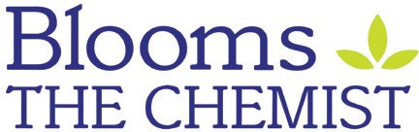
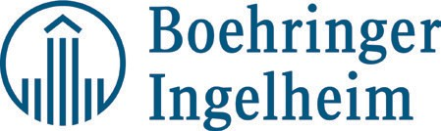
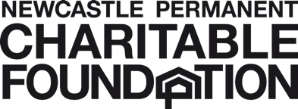

Website partners
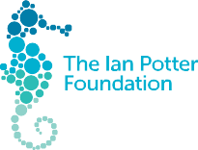
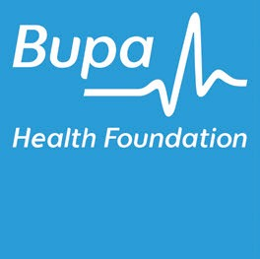
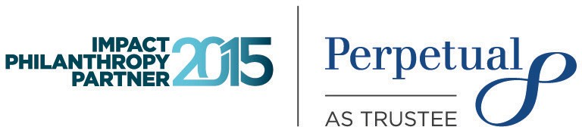
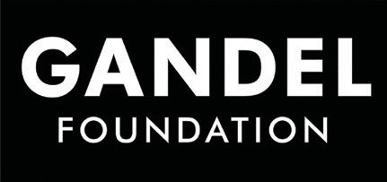

Supporting partners
Abbvie Ahrens Group
Alpha Strength Angels Initiative Annie Danks Trust
Arrive Wealth Management Arnold Bloch Leibler
Australian Physiotherapy Association
Aveo Robertson Park Residents’ Fund
Blue Label
BHP Olympic Dam Bupa Care Corner
Bristol-Myers Squibb & Pfizer Alliance
CAGES Foundation
Corrs Chambers Westgarth Count Charitable Foundation Dell Technologies
The Elizabeth & Barry Davies Charitable Foundation
Erica Foundation Eukanuba
Fired Up Group Halcyon Finance Ipsen
J.J Richards Waste & Recycling
The Lionel & Yvonne Spencer Trust
Marmalade Melbourne Medtronic
NAB Community Nexia Melbourne
O’Brien Accountants and Advisors
Omron Healthcare OzCAD
Pilot Athletics
Pumpseal Sales Technology Solutions
PSC Foundation Ritchies Stores RMBL Investments Ryman Health Care Silverline Medical
Thermo Fischer Scientific
Total Window Concepts
The William Angliss Charitable Fund
Wisewould Mahony Yardstick Advisory
The Yvonne and Lionel Spencer Charitable Trust

Government partners
Australian Government
National Disability Insurance Agency (NDIA)
Information, Linkages and Capacity Building (ILC)
Department of Industry, Innovation and Science – Medical Research Future Fund (MRFF) Emerging Priorities and Consumer Driven Research (EPCDR) Initiative
MRFF Cardiovascular Health Mission
Department of Social Services

State Government
Australian Capital Territory Government
Queensland Health
Tasmanian Department of Health and Human Services
Western Australian Department of Health
New South Wales Department of Health

Other partners
Health and charity partners
Cancer Council Victoria Cochrane Australia
Diabetes Australia (Queensland)
Murdoch Children’s Research Institute
National Heart Foundation

Key Alliances
Australian Chronic Disease Prevention Alliance (ACDPA)
Australian Living Evidence Consortium
Australian Stroke Alliance Australian Stroke Coalition World Stroke Organization

Gifts in Wills Supporters
We were very grateful to receive generous gifts from the following wonderful supporters who thoughtfully included a gift in their Will to Stroke Foundation.
Jeanette Alfredson
Kathleen Allen
Shirley Apelt
Peter Augustes
Geoffrey Bentley
Dolly Berwick
Irene Blair
Joy Bossini
Helen Jean Burgess
Nola Bren
Isabella Campo
Muriel Coventry
Michele Day
Betty Dickinson
Robert Donnan
Aleida Ekkel
The Late James Fairfax AC Susan Fluellen
Francis Goudge
Geoffrey Gover
Richard Graham
Michael Harriss
Norman Heidemann
Rita Hughes
Patricia Hunt
Margaret Hunter
Rex Johns
Yvonne Jones
Lynette Keogh
Dorothy King
Mildred Lapthorne
Ian Lester
Allan Lorraine
Helen Mackenzie
Mrs Matheson
Leslie Maurer
Patrick McDermott
Douglass McDonough
Joan Mein
Francis Meldrum
Muriel Ming
Peter Mitchell
Joan Neumann
Vincent Pengilly
Marie Preston
Beryl Elizabeth
Raymer Leslie
Richards
Tanya Roddan
Hilda Rose
Allan Rowling
Gertrude Tatzel
Valerie Thorburn
Jacqueline Turner
Sylvia Wade
June Weller
Reginald Glenn Wotherspoon

Major Donors
Mr Michael Ahrens
Mr & Mrs Geoff & Robin Aubourg
Mrs Rita Andre
Will & Dorothy Bailey Charitable Fund
Mr & Mrs Leo & Ann Browne Mrs & Mr Barbara &
Ian Butler
The Jack and Hedy Brent Foundation
The L.R Cazaly Trust Fund
Mr Neville Castles
The Ronald Alan Curry Trust The Edward C Dunn Foundation
Dr Michael Gronow
Dr Margaret Harding
The Halifax Foundation
Mr & Mrs Bill & Alison Hayward
Kingfam Foundation
J & E King Family Foundation Limited
Mrs Sylvia Miller Mr Sam Miller
Graham and Pam Nock Foundation
Mr & Mrs David & Glenys Overton
The Henry Pollack Foundation
Annie & John Paterson Foundation
Ms Jill Ross-Perrier
Mrs Dianne Shakespeare
The Sun Foundation Pty Ltd Miss Jane Rich
Ms Enid Swain
Lady Marigold Southey AC Ms Jennifer Tatchell
Mr James Tait
Ms Marietta Tooher Wheatley Family Foundation Mrs Jean Williamson
Counterstroke Golf Classic Committee
Dee Clements (Co-Chair) Chris Reilly (Co-Chair)
Libby Cotton
Caroline Ennels
Ross Eddy
Ian Gardner
Graeme Hall Helen Angus

Major Community Fundraisers
Tasmania Iconic Walks Committee
Jo Cordell-Cooper
Marg Marshall
Melinda Williams
Linda Britts
Caroline Gray

Tasmanian Iconic Walks – Team Motivational Sneakers Matt Picone
Matthew Rossendell
Renee Hunt
Elise Dewar

4 Points Australia
Tommy Quick

Men’s Health Awareness Ball
Vik Bhandari

Maria Venuti Concert
Bianca Venuti

In memory of Cathy Aguilar
Alex Aguilar

Towel Challenge
Lee Carseldine
David Genat

Stride4Stroke Training with mates
Daniel Maitland (Captain) Rebecca Maitland
Lily Smith
Eleyne Spencer
Georgie Whittle
Lindsay Anderson
Julia Smith
Amy Hibberd
Ciara Scott
Rachel Franklin
Sammie Johnson
Paul Fink
Joel Mckee
Peter Monahan
Scott Mcgregor
Sophie Durnan
Colin Beeby
Shona Evans
Angus Octigan
Michael Todd
Emile Trainer
Harrison Spencer
Anthony Selby
Robbie Anderton
Patrick Smith
Pezet Pacers
Angela Mulcahy
Tim Pezet
Daniel Pezet
Hannah Duggan
Emily Style
Daniel Style
Chris Pezet
Janelle Champney
Annette Pezet
Stephen Pezet

PAW and Associates
Sara Williams
Miriam Williams
Jacinta Williams
Marianna Moore
Prudence Williams
Xavier Williams
Siobhan Williams
Alexandra Williams Francesca Williams
Alan Williams

Box Hill Stroke Team
Alicia Lawrence
Tee Fraser
Bailey M
James Thomson
Penny Pendrey
Judi Boothroyd
Claire Rossi
Lorraine Mcdonald
Bec Mathews
Hannah Boreham

Kathy’s Power Walkers
Hannah Castle
Trent Avery
Lauren Vincent
Brett Castle
Heather Young
Lyn Vincent
Greg Vincent
Rod Avery
Matthew Magin
Samanth O’toole

Mandi & Co – On the Run
Amanda Newstead
Naomi Clayton
Luke Thomas
Cass Ponchard
Tracey Laverick
Leonie Lewis
Penny Genoli
Teresa Capobianco

Hike for Health – Larapinta Trek
Priya Sharma
Cindy Tan
Ashlea Needham
Andrew Ross
Alex Reed
Trina Wood-Brown
Peter Hoang

Melbourne Marathon
Adam Jarvis
Luke Jarvis

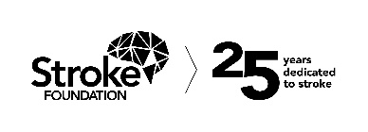

Stroke Foundation would like to thank the many thousands of people who have generously donated their time and money to ensure we are here to support all Australians whose lives have been changed by stroke.

Contact us

1300 194 196
strokefoundation.org.au
/strokefoundation
@strokefdn
@strokefdn

How to get more involved
Give time – become a volunteer.
Raise funds – donate or hold a fundraising event.
Speak up – join our advocacy team.
Leave a lasting legacy – include a gift in your Will.
Know your numbers – check your health regularly.
Stay informed – keep up-to-date and share our message.

